**Data Visualization and Signal Processing**

1. **Introduction**

We will be using methods used to plot sampled data from sensors on the Olimex MSP430 and Arduino 101 boards. Then we would clean up the collected EMG signals and extract the desired signal features using basic signal processing methods.

1. **Objective 1 – Plot Raw and Scaled EMG Signals**
2. The first part of this objective is to modify the Arduino code from Lab 2 and use it to implement interrupt based sampling to collect data just from one Analog input (A0).
3. The Olimex is connected to the Arduino board at the analog input A0.
4. In the Arduino code, I set up a Frequency variable to achieve the target sampling rate of 200Hz. Frequency = 200.
5. We modify the Arduino code to get the raw ADC values and the time at which the values have been sampled.
6. The precision is microsecond – so I used the inbuilt function micros ().
7. The code is calibrated to record values for 5 seconds.
8. After running the code, we set up the python script to read the data from the serial port and modify the code to write the data to a text file (the user can specify the name).
9. We collect the raw EMG input from the board and calculate the time and save them in a user-friendly format.
10. After we record this data, we are asked to provide 2 subplots.
11. For the first subplot, we graph the EMG reading along with time (in microseconds) – time being the X axis and the EMG sample value being Y-axis.
12. After labeling the graph and the axis, we move to subplot 2.
13. We must scale the EMG sample values to a voltage and plot the first 5 seconds of data collection.
14. In this subplot the time axis is recalibrated to present time in seconds (instead of microseconds).
15. After saving the data I print out a message – saved to make sure that the file is complete.
16. My offset value is 1.5
17. I initiated the program and without connecting the wires to my arm, I read the values from the serial port.
18. After some values, the average value comes out to be 1.5, this is my offset value.
19. My scaled value is 1023.
20. I derived this value based on the observation that the Arduino ADC has a 10-bit precision, so this value is between 0 and 1023.
21. This finishes our Objective 1 for Lab 3

Figure 1: Arduino Code for Objective 1 (Data sampling using interrupt sampling method)

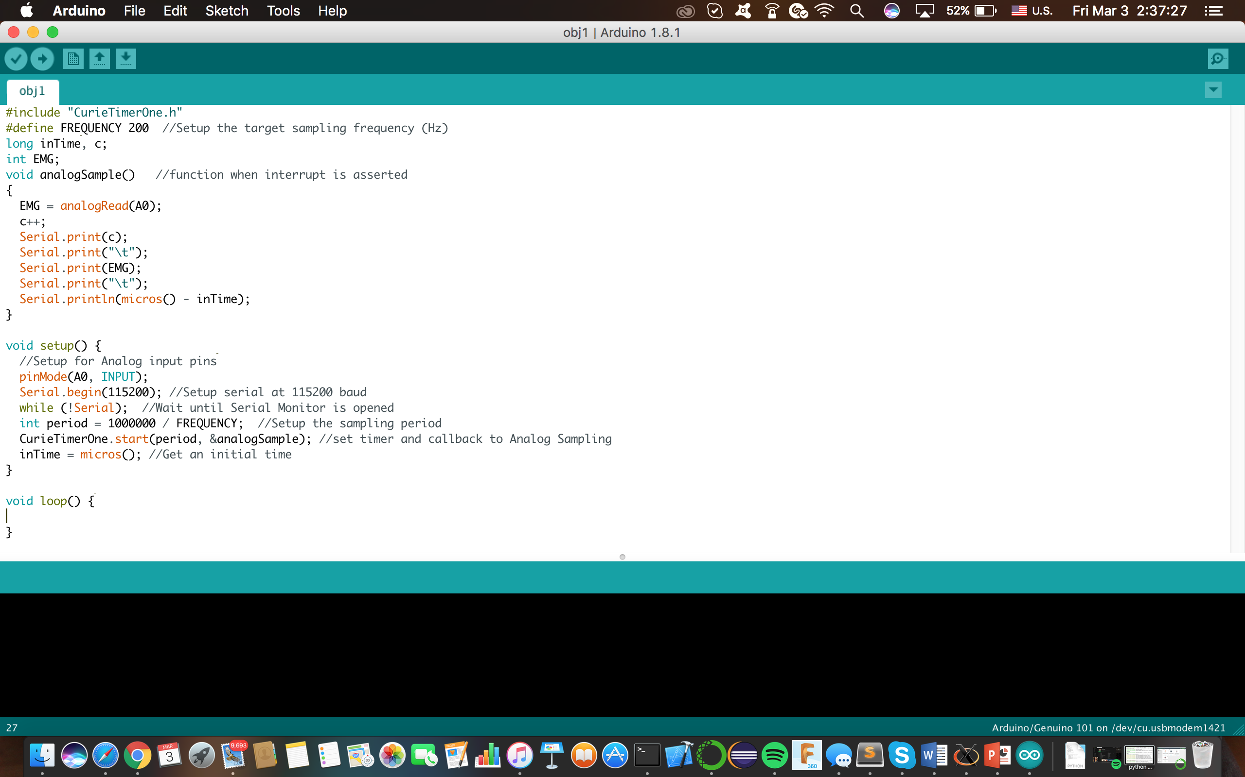

Figure 2: Python code for collecting data from the serial port and then writing it in a text file. The data is saved in the raw format.

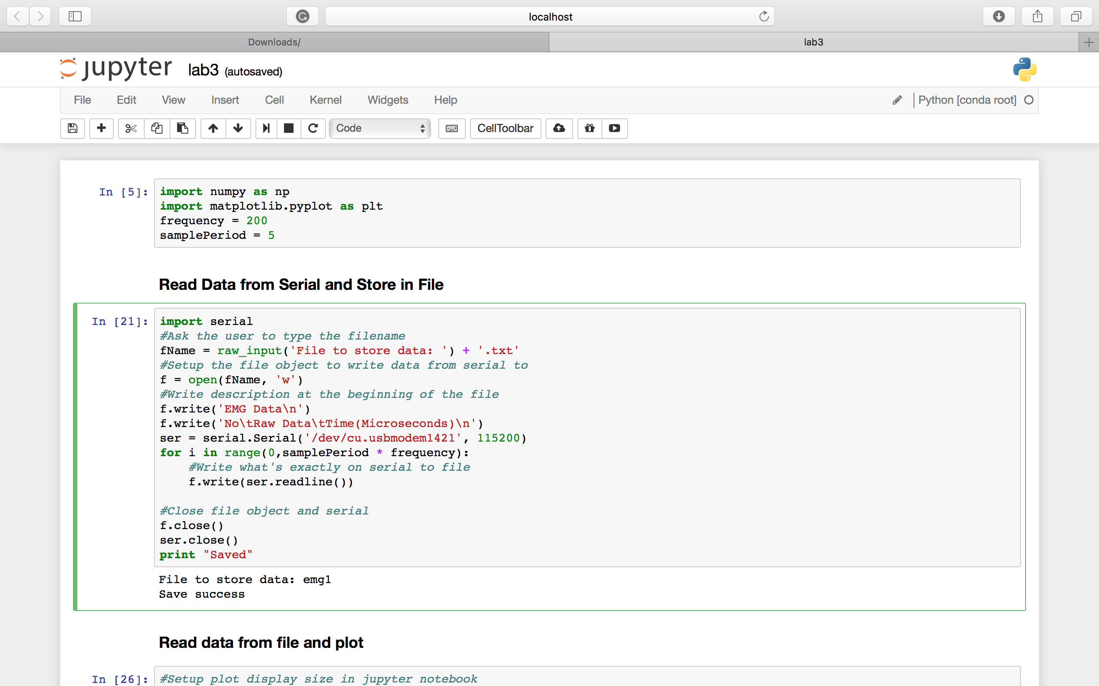

Figure 3: Python code to read the data from the file and then plotting the two subplots.

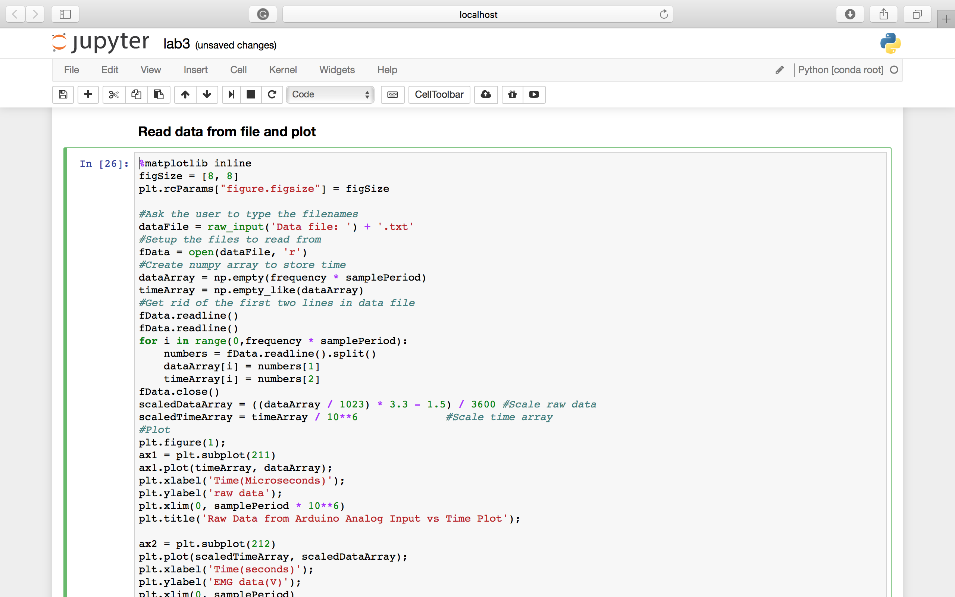

Figure 4: Code contd.

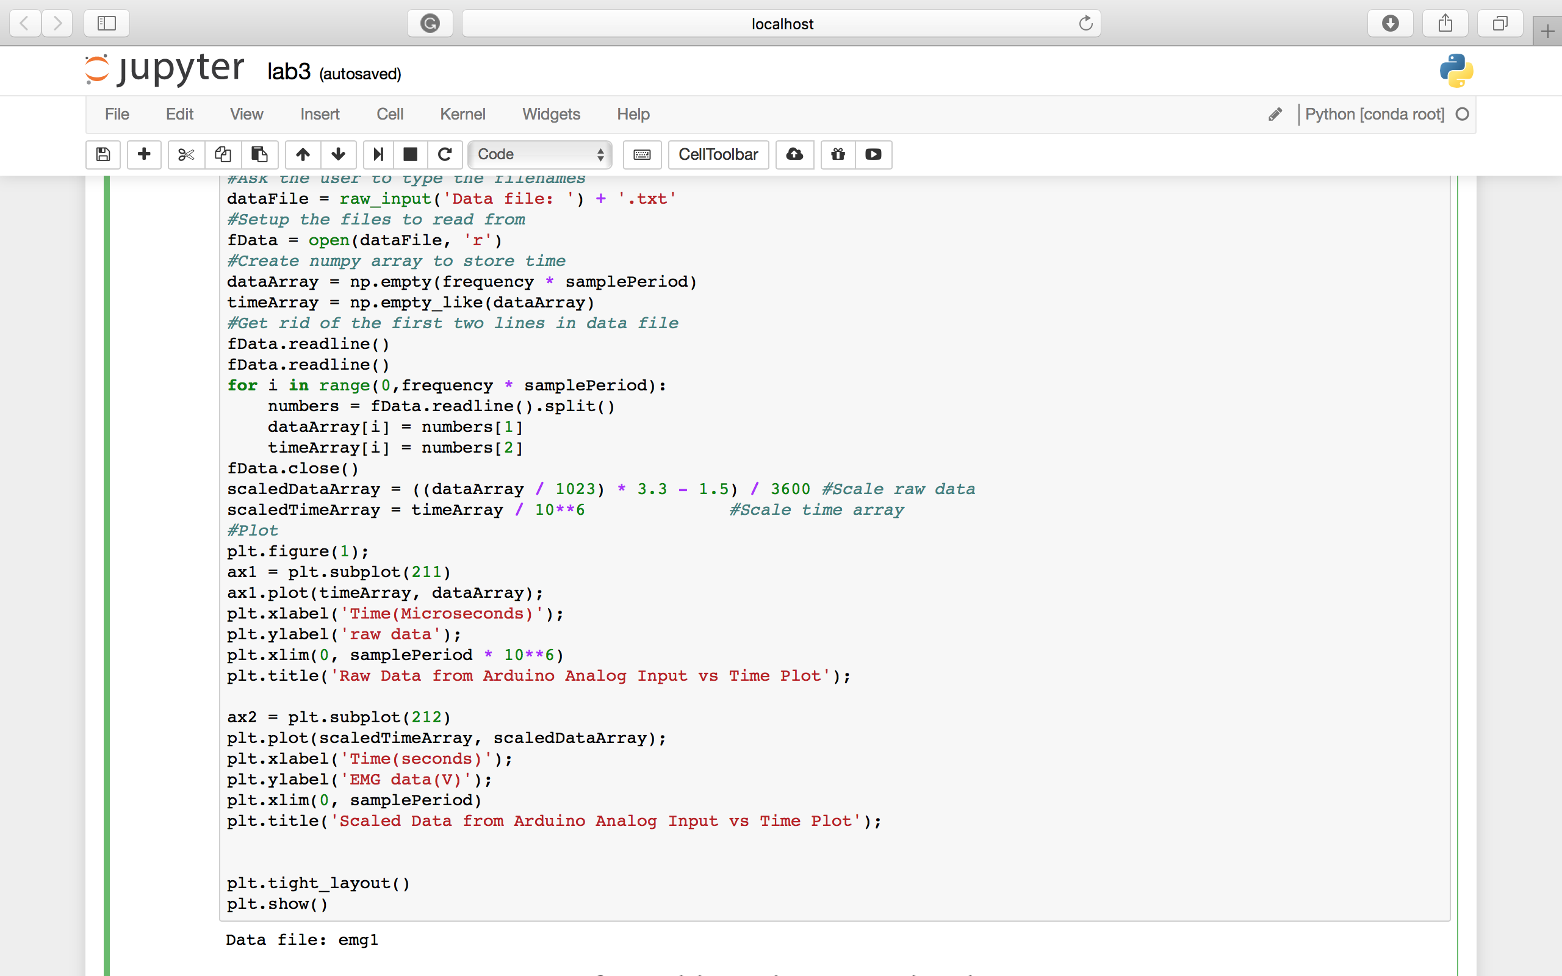

Figure 5: Subplot 1 – 5 seconds of raw EMG data against time (in microseconds).

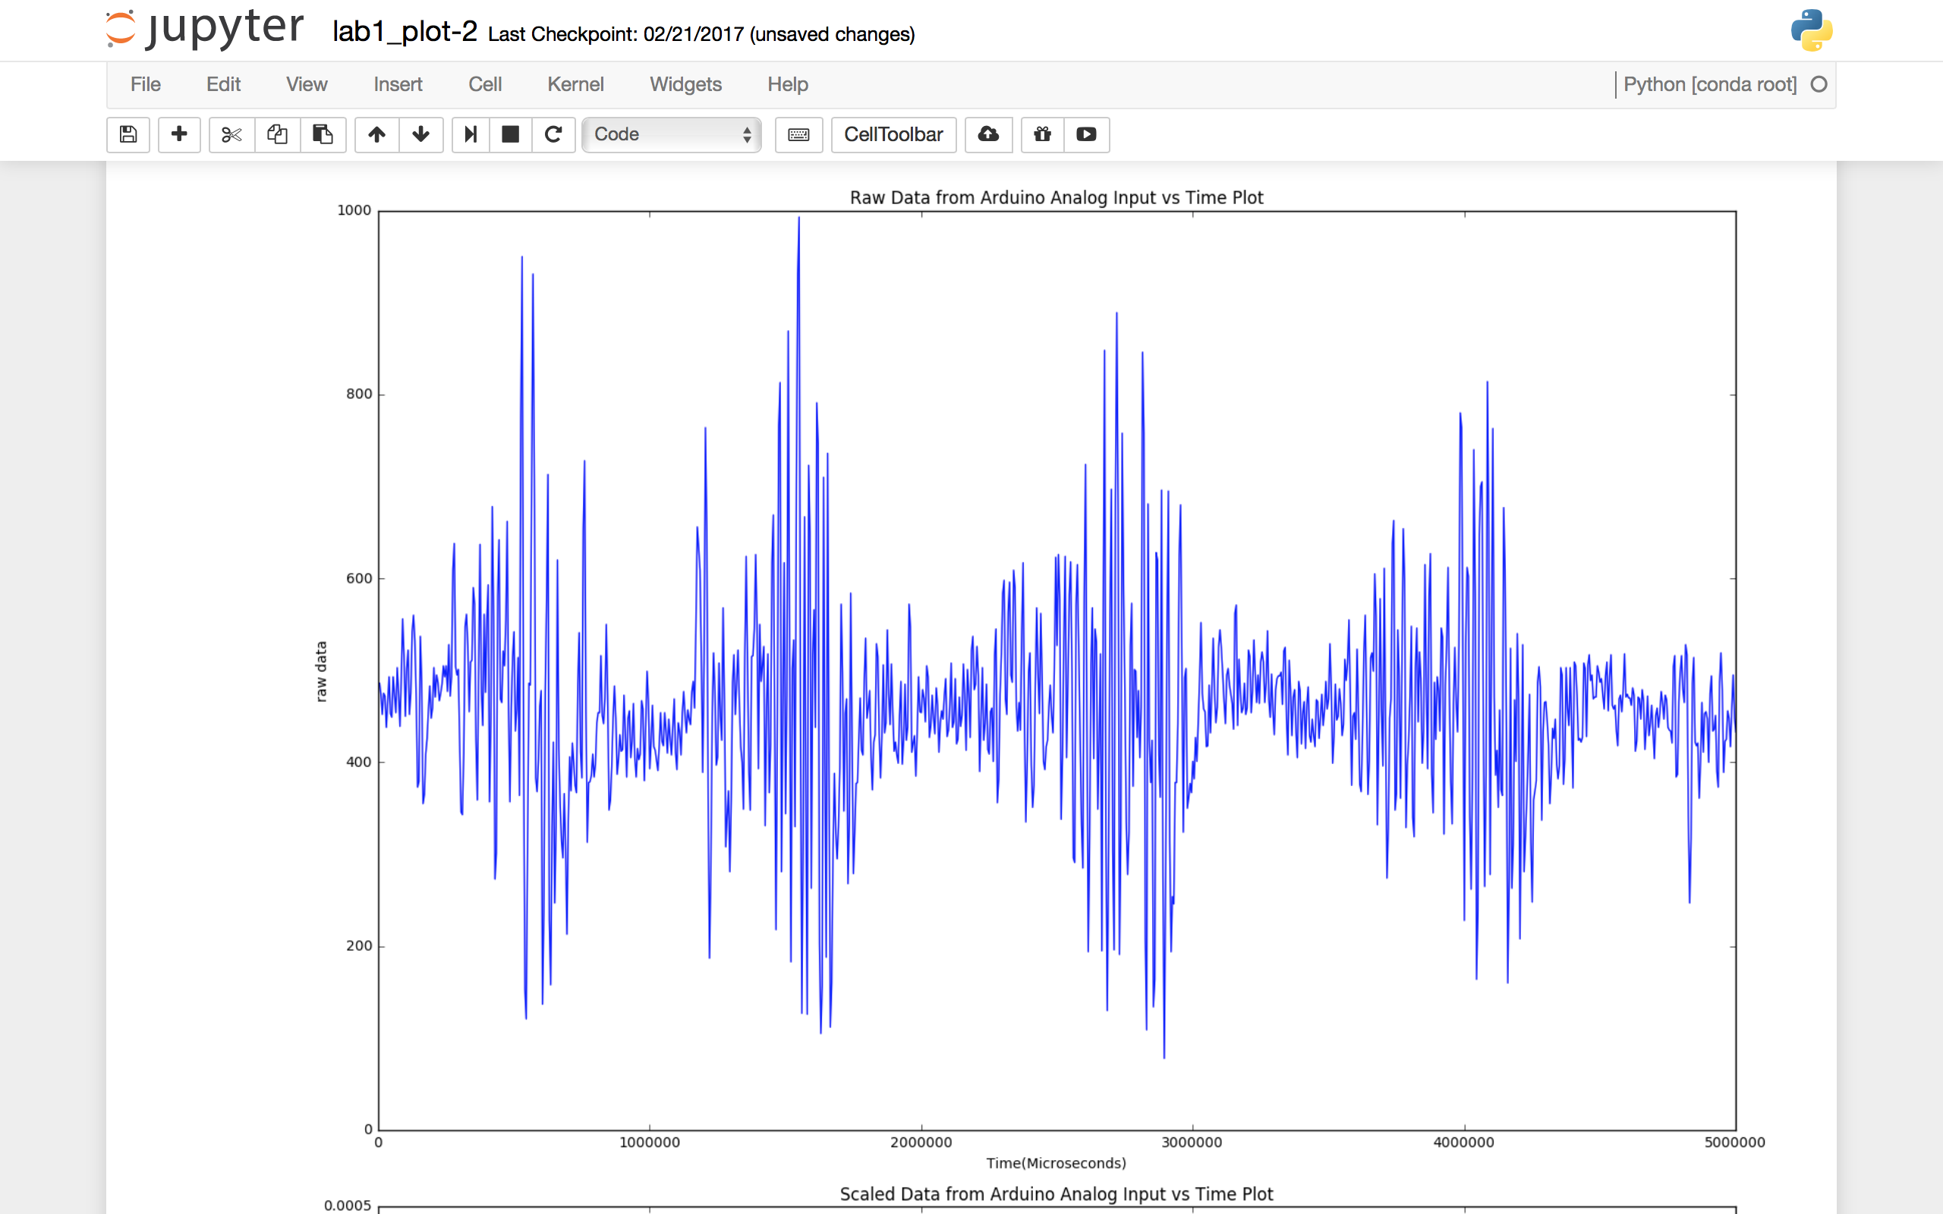

Figure 6: Subplot 2 – Plot of Scaled data in Volts against time (in seconds).

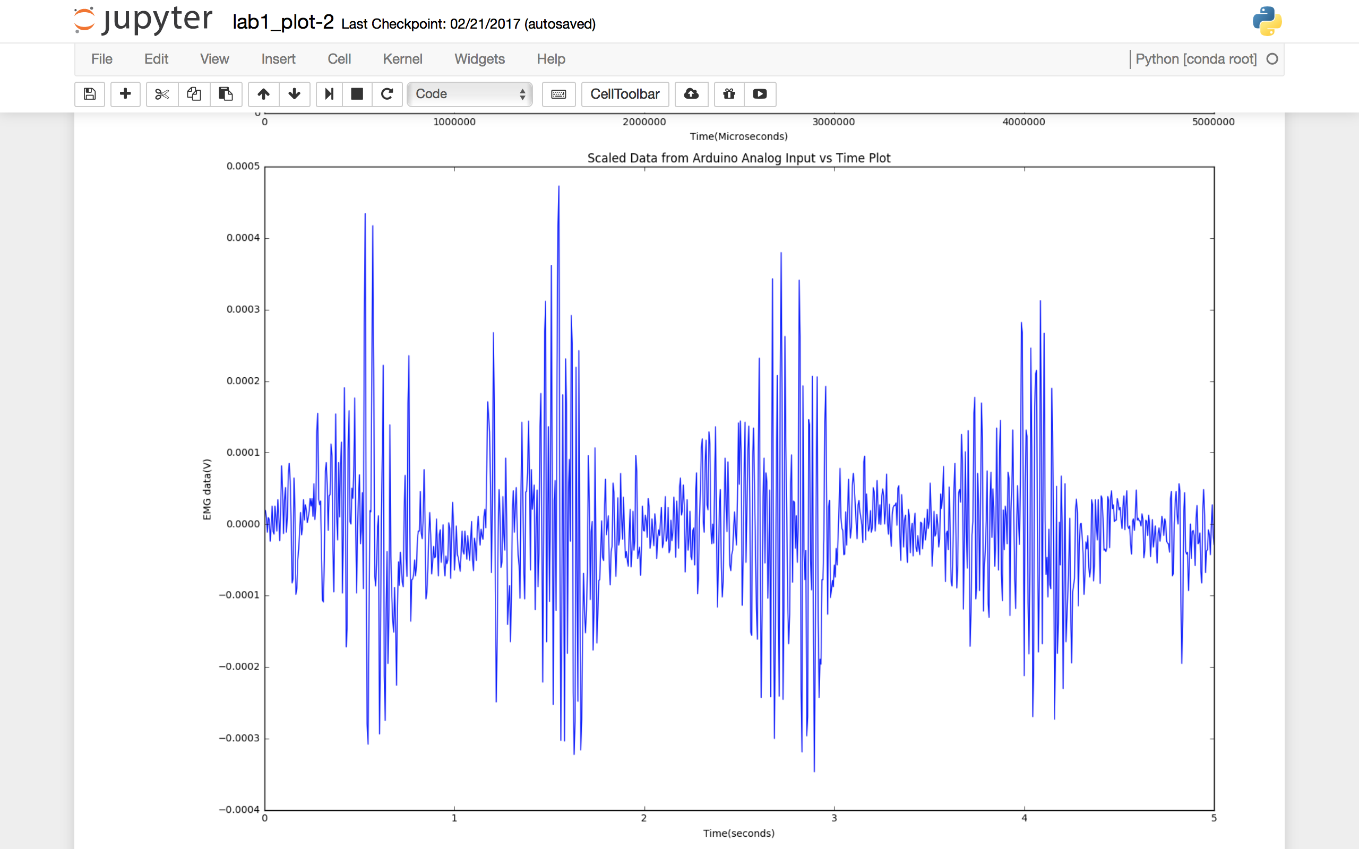

1. **Objective 2 – Signal Filtering, Rectification, and Power Estimation**

.

* 1. The first part of this objective is – high pass and low pass filtering.
  2. These are digital filters.
  3. Our data, right now, has way too much noise caused by cable movement, mobile phones and static current.
  4. Though the EMG shield hardware includes both high and low pass filters, we still apply some digital filters to make our data and presentation more accurate.
  5. To reduce the effect of bias we must use a simple high-pass filter.
  6. I just add the following line of code (already provided by the instructor) in my python script which calculates the coefficients of high pass filter (first line) and then applies that filter to an input signal (second line). The code is – b_high, a_high = scipy.signal.butter(3, 0.1, ‘high’, analog=False) signal_out = scipy.signal.filter(b_high, a_high, signal_in).
  7. To avoid too much high-frequency voice we apply a simple low-pass filter. I used the following lines of code to achieve this – b_low, a_low = scipy.signal.butter(3, .5, ‘low’, analog=False) signal_out = scipy.signal.lfilter(b_low, a_low, signal_in).
  8. I add a print statement at the end of these lines of code to get a sense of what a_low, a_high, b_low and b_high have.
  9. After that I make another subplot to plot another 5 seconds of data from the data file we generated before.
  10. This time, the data represented in the plot will have both the digital low and high filters.
  11. The plotting of this graph finishes first part of objective 2 for Lab 3.
  12. To make the plots more readable I have added three lines of extra code on top of the code. This prevents the graphs to overlap.
  13. The second part of this objective asks us for rectification and smoothing of the obtained graph.
  14. We know that a simple strategy for EMG power estimation is full wave rectification and smoothing.
  15. For this part, we are printing 3 plots
      1. The filtered EMG output (after applying high-pass and low-pass filters)
      2. The rectified signal
      3. Power estimation by smoothing. For this we will be using a moving average of 100 samples of data.
  16. For this we must create a “box car filter”.
  17. I have used the following commands provided by the instructor to achieve this – box = scipy.signal.boxcar(100) signal_out = scipy.signal.lfilter(box, 1, signal_in)
  18. Plotting the first 5 seconds of the data from our file, we finish the part 2 for objective 2 and hence Lab 3.

Figure 7: Code for Part 1 of objective 2

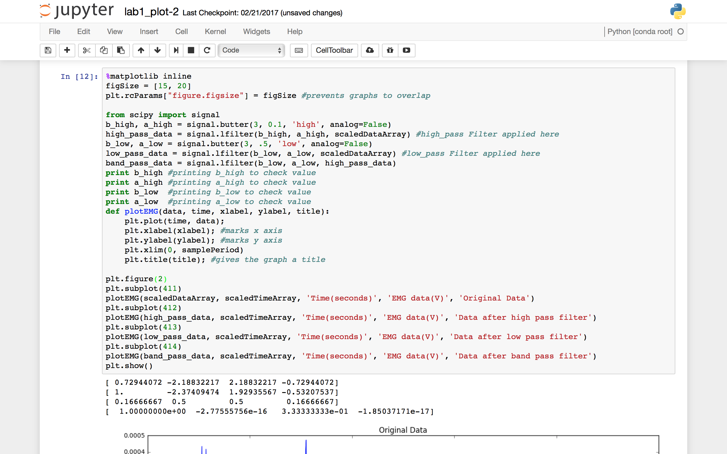

Figure 8: Original data and High Pass filter plots

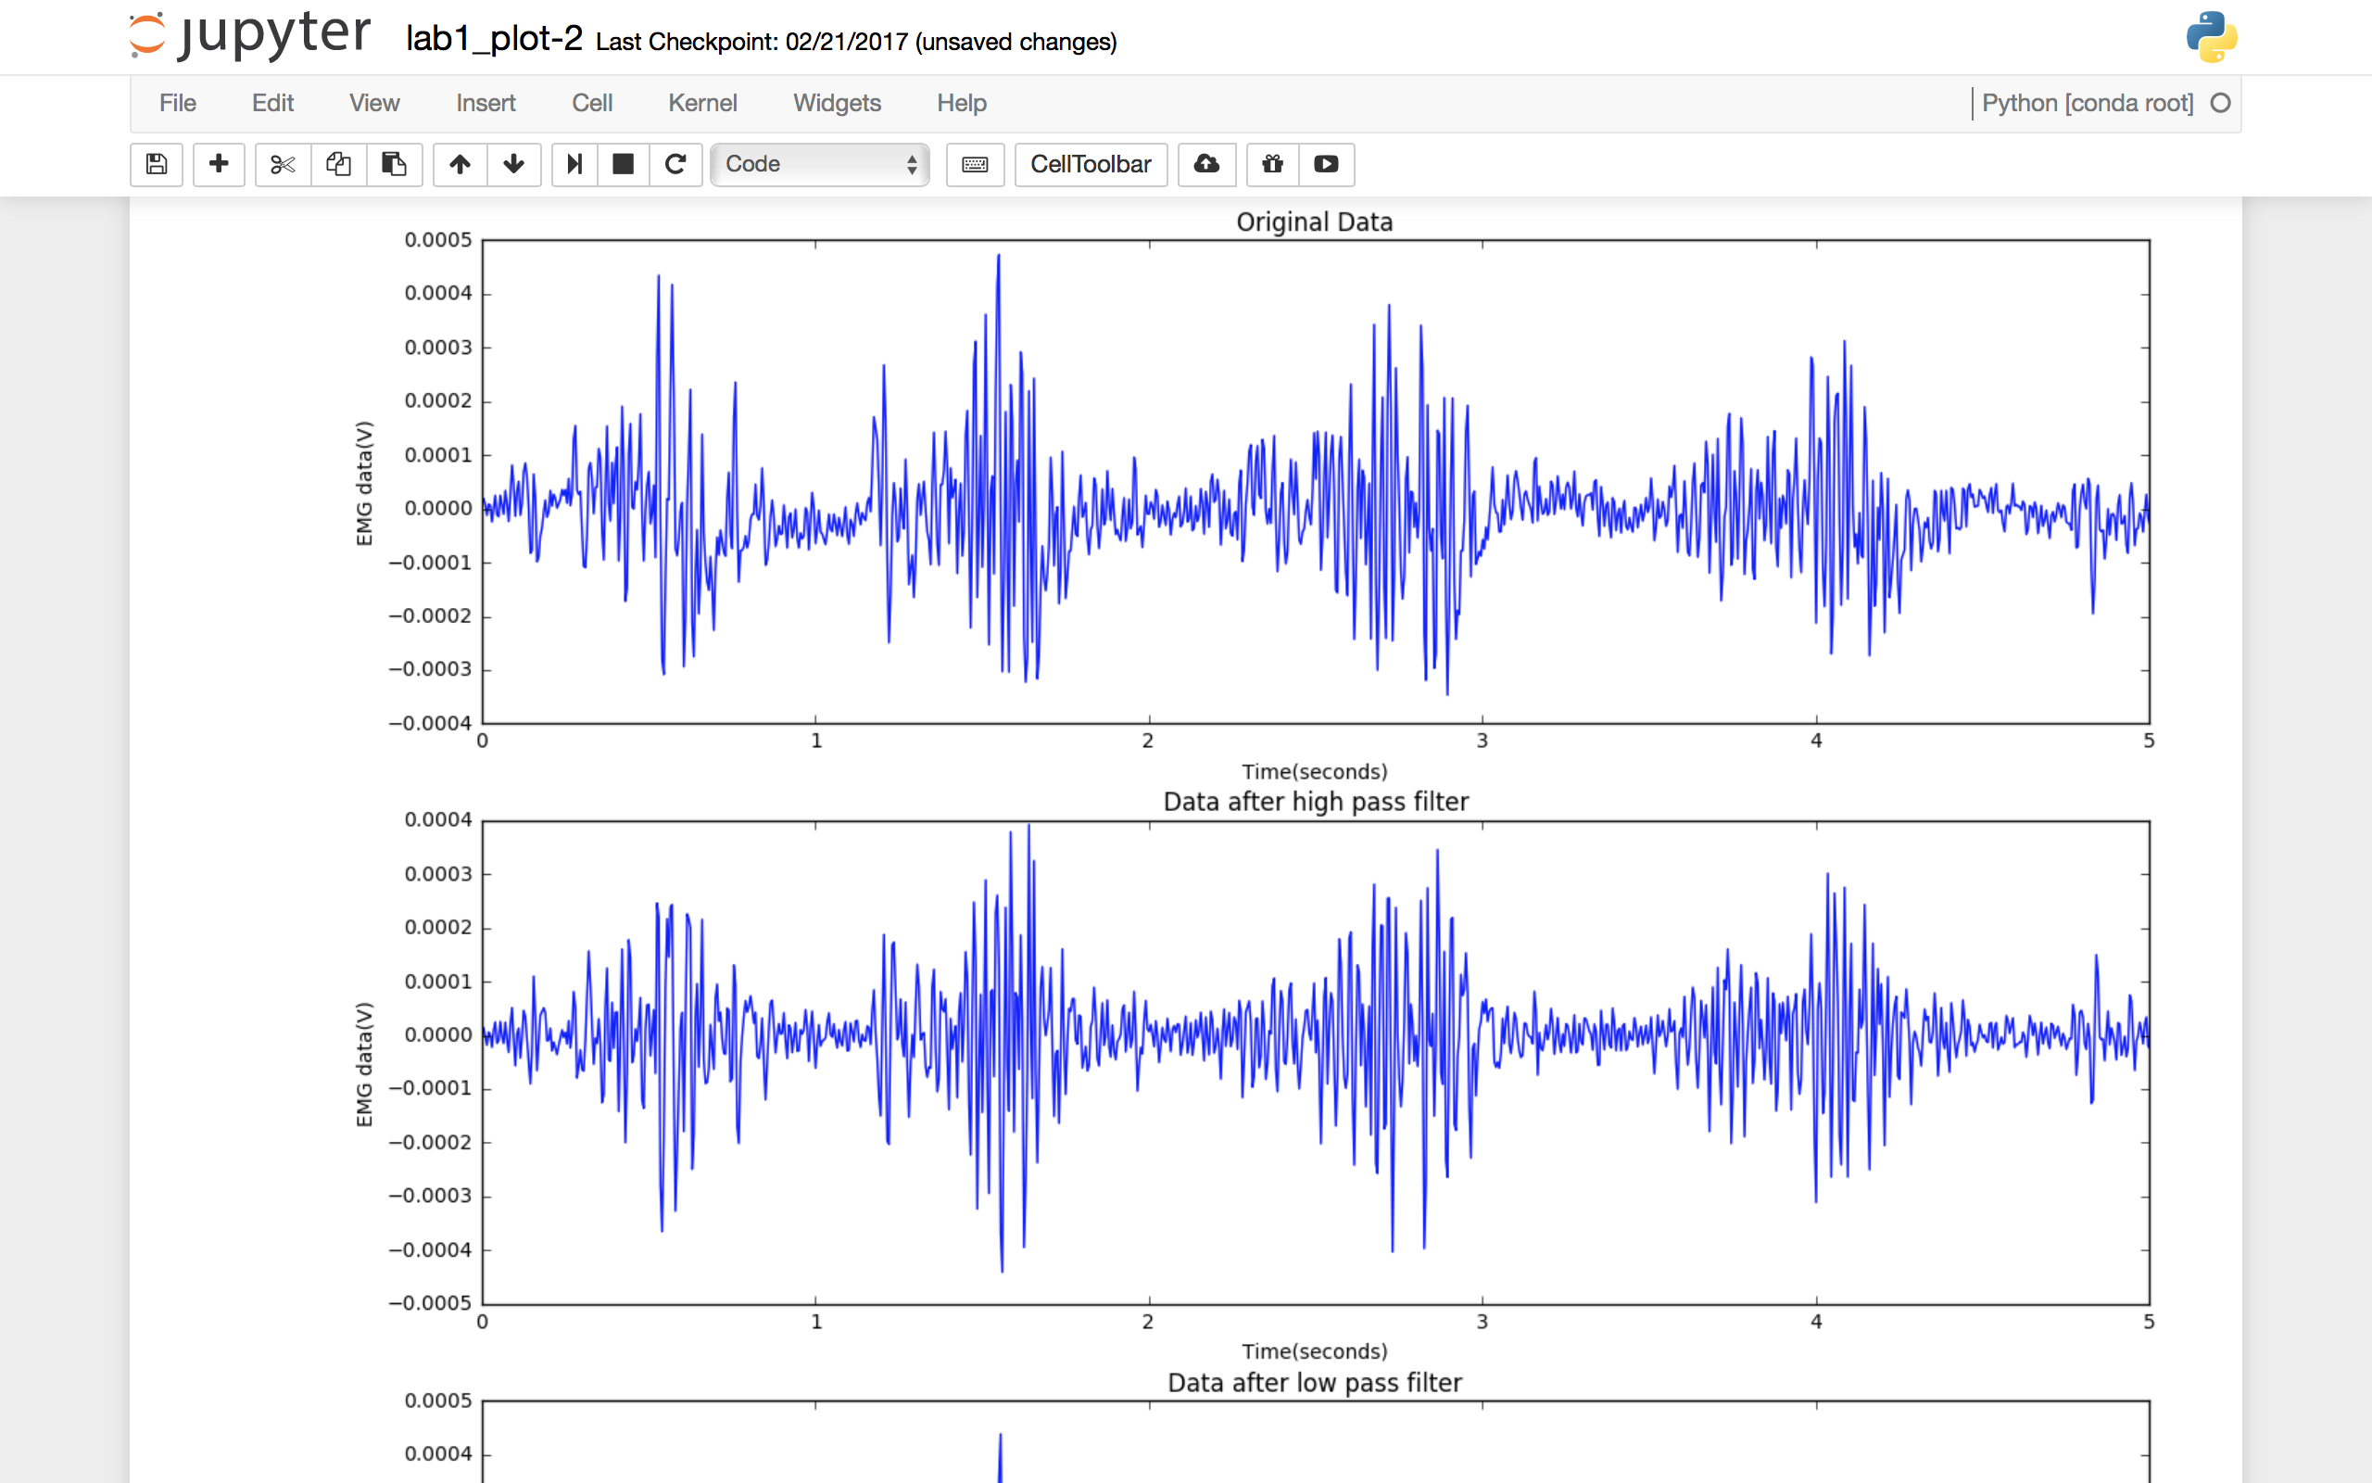

Figure 9: Low Pass filter and Band Pass Filter plots

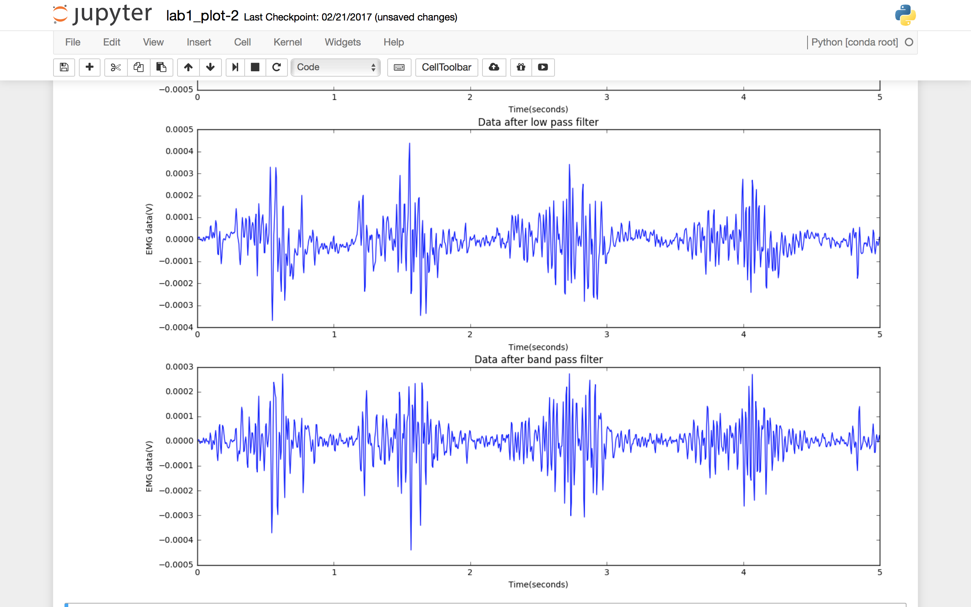

Figure 10: Code for Part 2 of Objective 2

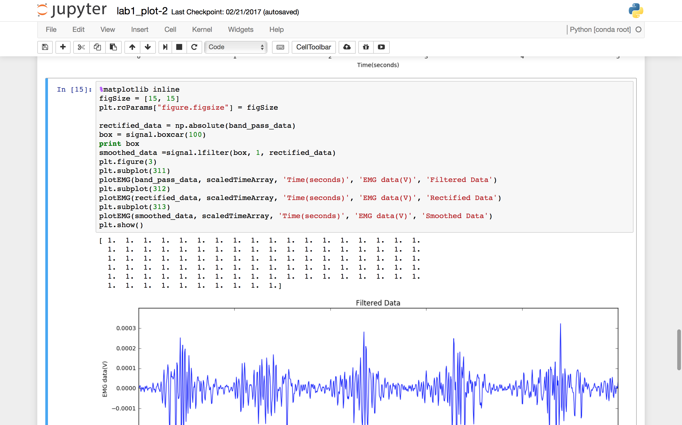

Figure 11: Filtered Data and Rectified Data Plots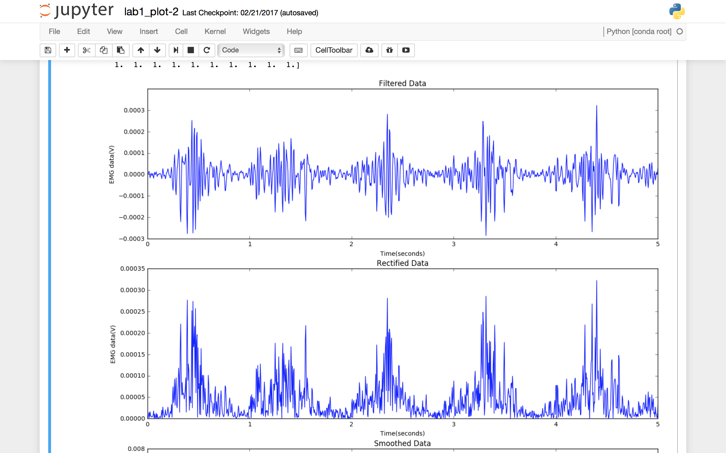

Figure 12: Rectified Data and Smoothed Data Plots

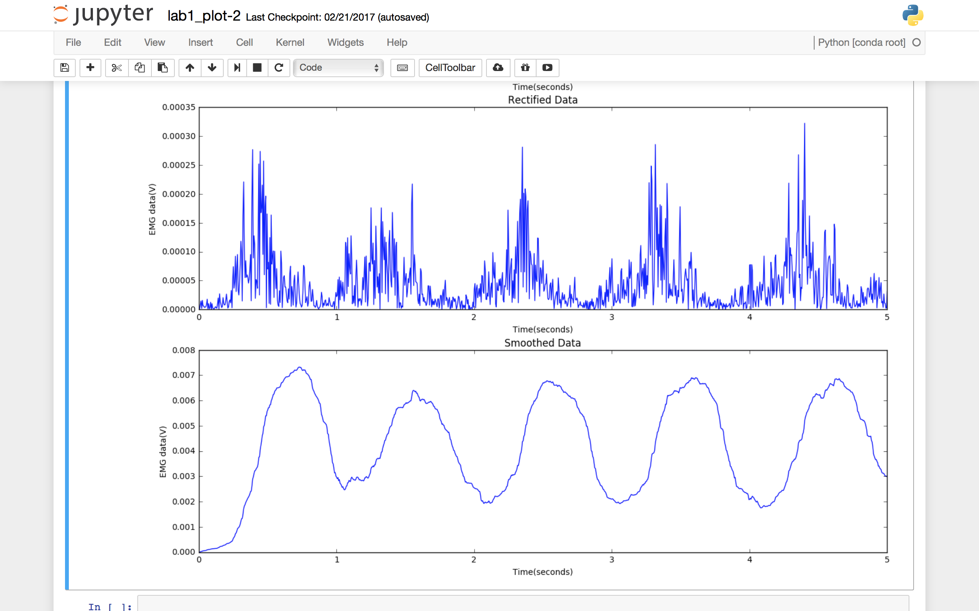

1. **Objective 3 – Real – Time Signal Processing on the Arduino!**
   * 1. In this objective, we will implement the same signal processing methods but this time on Arduino.
     2. The high and low pass filters used in the previous objective are called Infinite Impulse Response (IIR) filters.
     3. The IIR filters are very useful because of their simple structure and is majorly defined by the lists of coefficients.
     4. We try to achieve a similar thing but in Arduino.
     5. The structure of the filter forms a recursion over the values of the input signal recorded earlier and the output filter.
     6. I used b_high, a_high, b_low and a_low variables returned by scipy.signal.butter() function used repeatedly in objective 2.
     7. Per the writeup – I copied these values directly from the Arduino code as hard coded initializations.
     8. I used the given code to achieve some parts of this objective.
     9. In the previous objective, we were asked to use Python to process the signal and plot the output at every stage.
     10. For this objective, I must repeat the same processing process on the EMG signal and for every sample – print out every stage of the stage.
     11. To achieve this, I coded my Arduino code in a way that gets the EMG data from the Olimex board and convert data to usable units (filtered, smoothed and rectified).
     12. My python scripts then read the data from the Arduino and writes it in the obtained format and plot the graphs for every sample and stage.
     13. Also I switched to the highest baud rate supported by the Arduino for this objective as the data collected is so much more than the data collected in previous objectives.
     14. To verify the accuracy of my Arduino implementation, I use a python script to plot the data collected to generate graphs with each signal processing step (i.e. replicate all the graphs from Objective 2).
     15. There will be a total of six graphs
         1. The raw integer sample
         2. The sampled scaled to represent EMG voltage (in millivolts)
         3. The output of the high pass filter
         4. The output of the low pass filter
         5. The rectified signal
         6. The output of the boxcar filter

Figure 13: Arduino Code for Objective 3

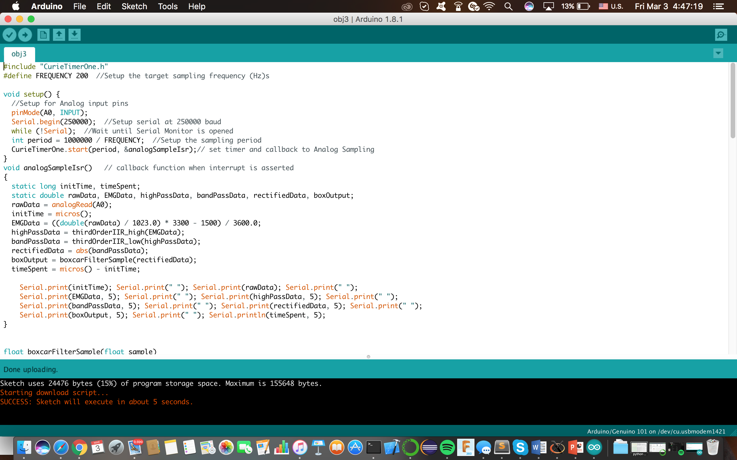

Figure 14: Code contd.

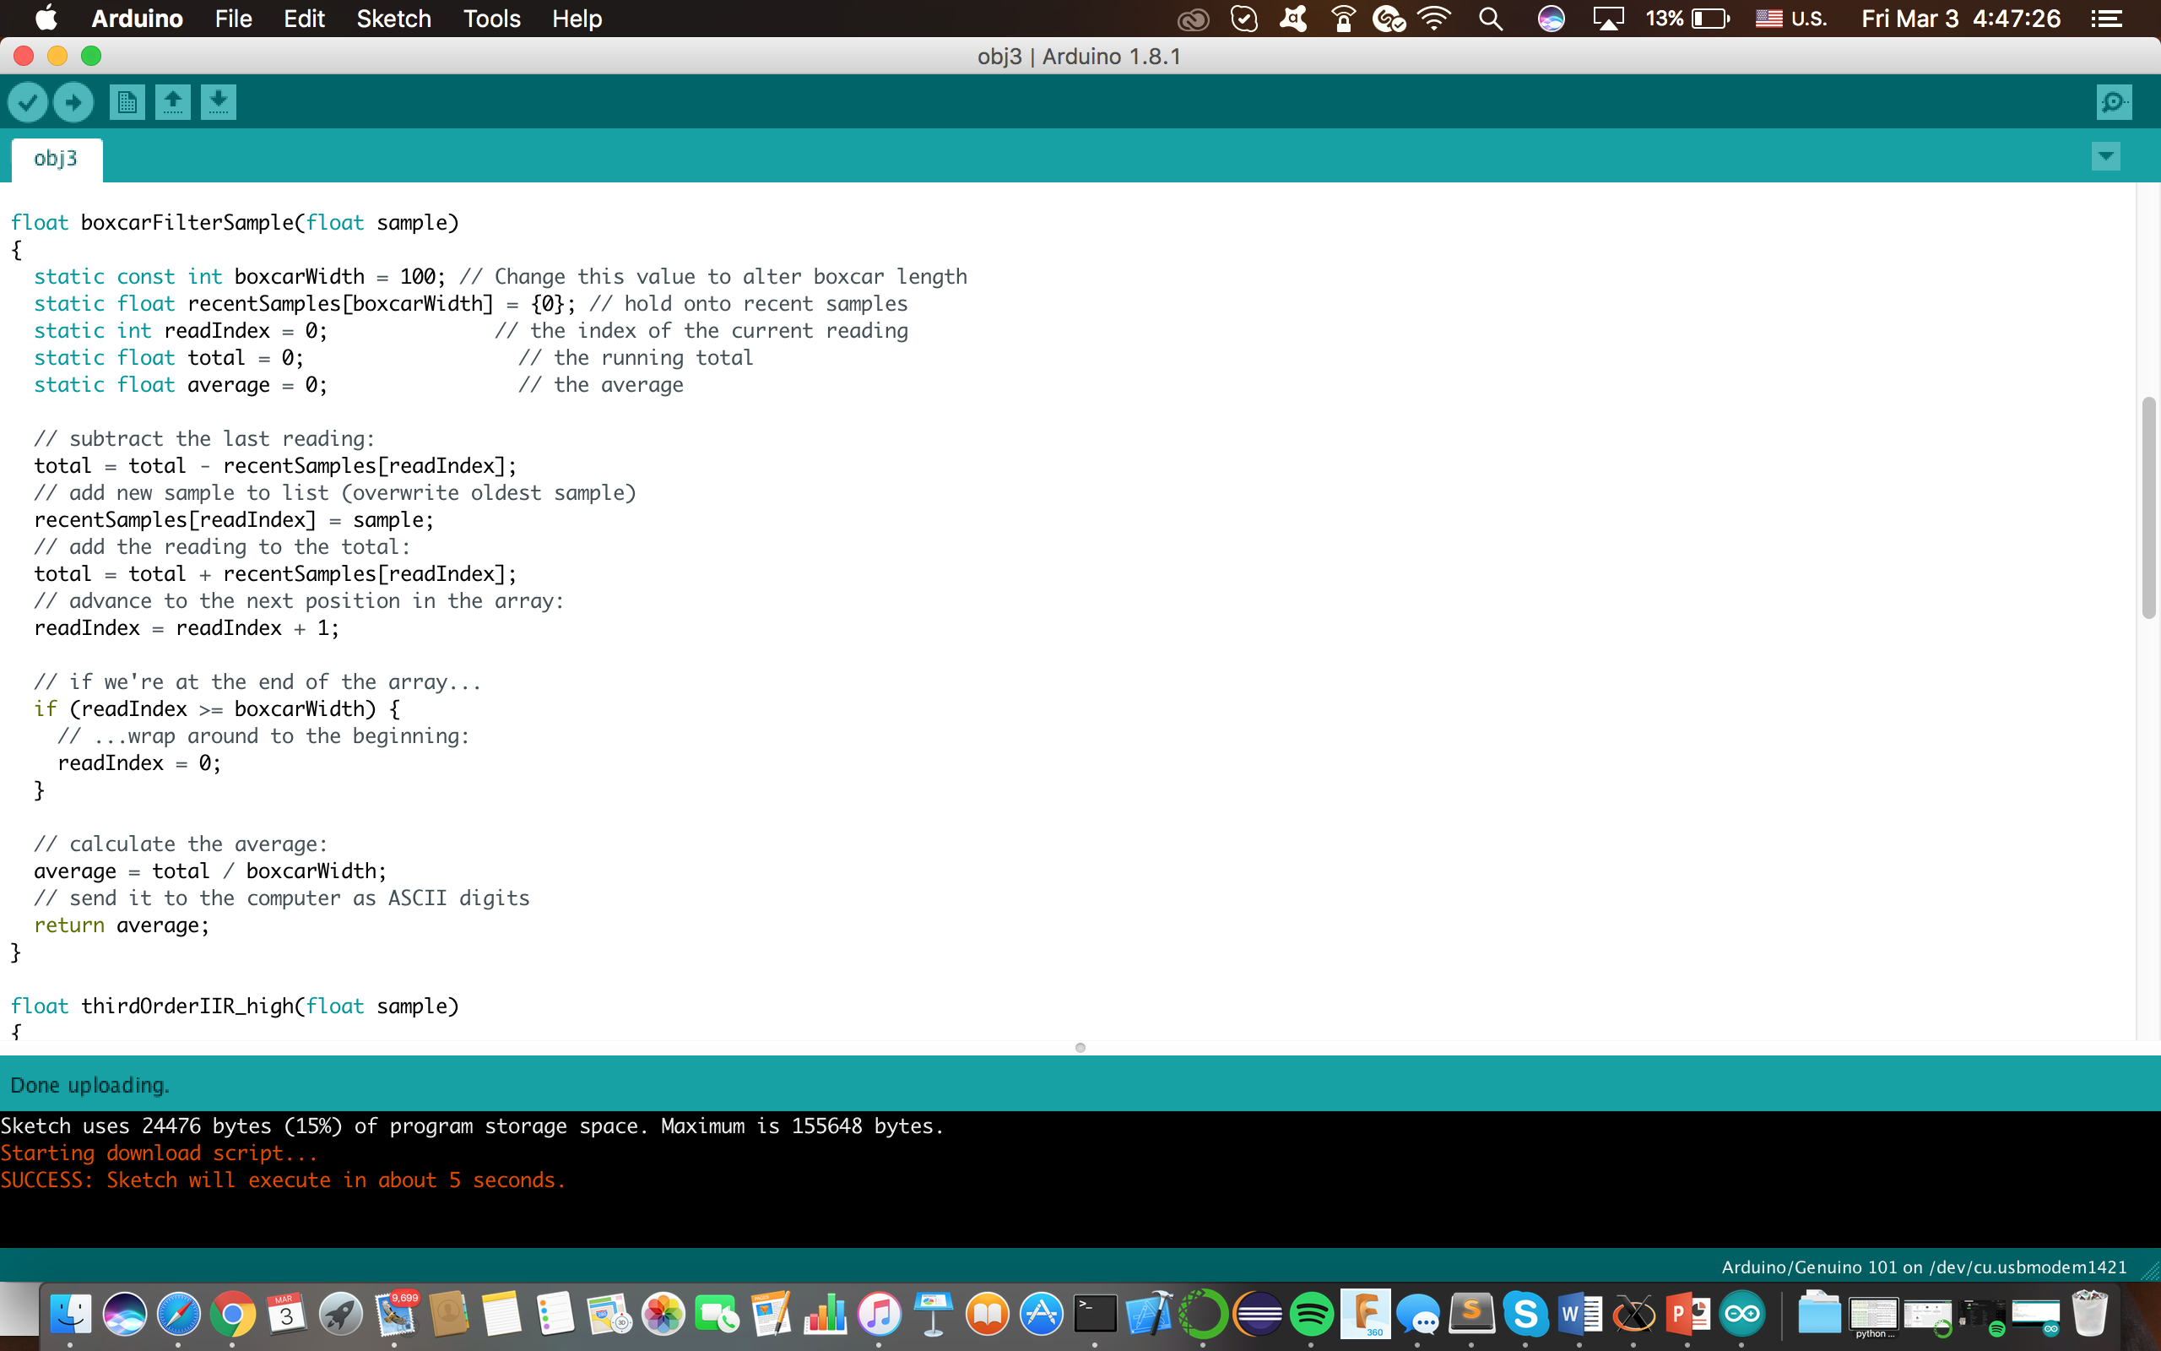

Figure 15: Code contd.

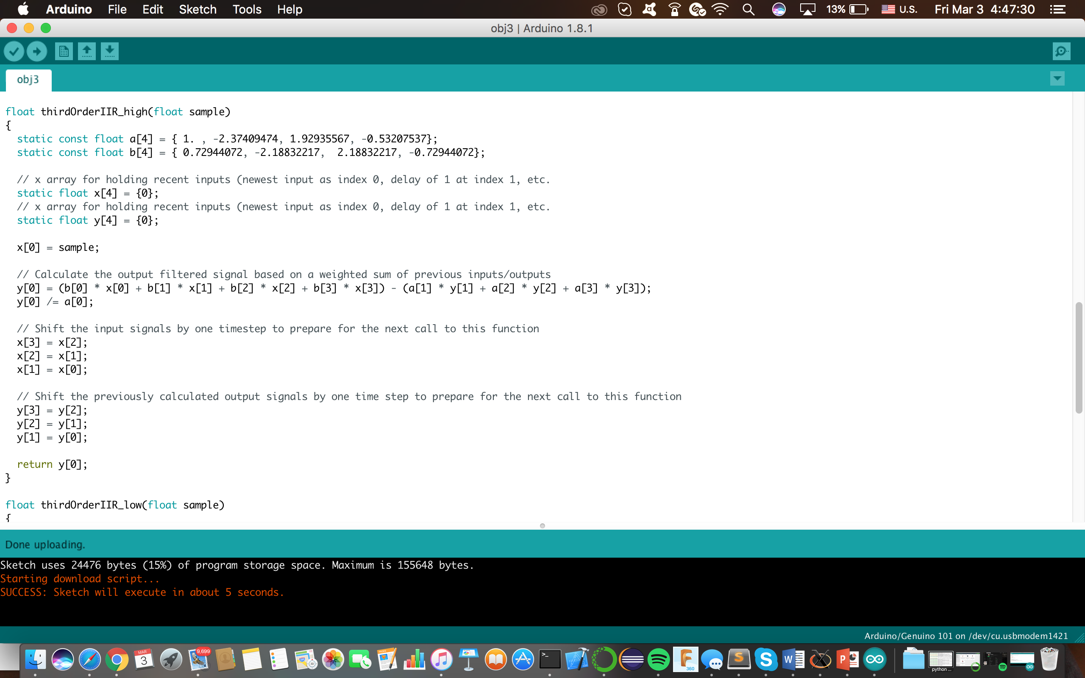

Figure 16: Code contd.

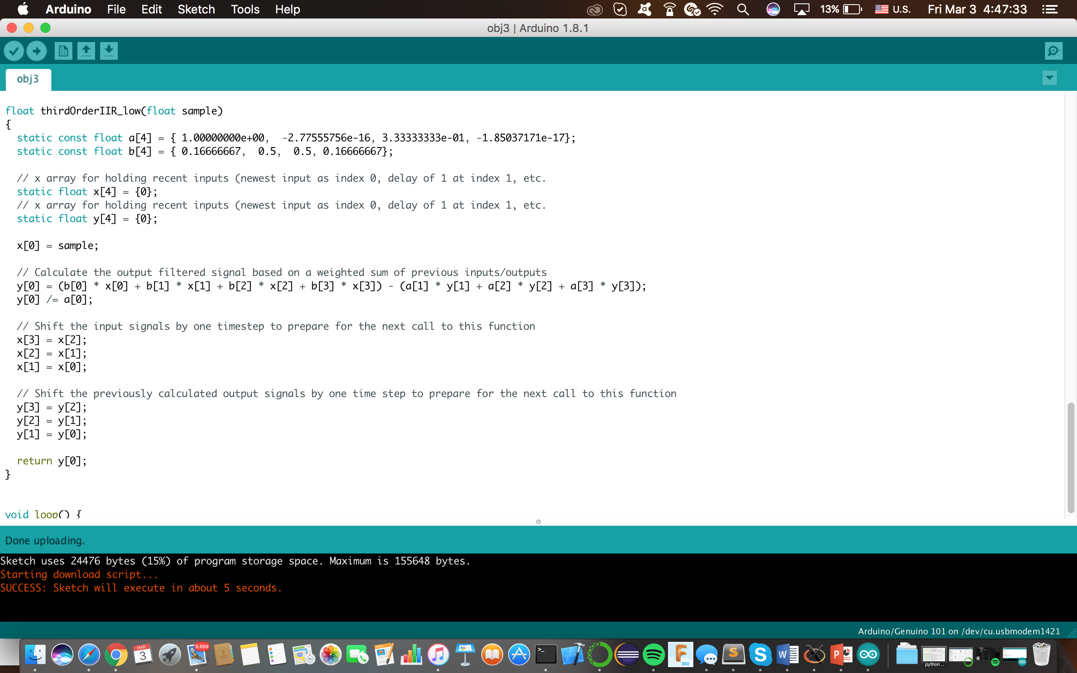

Figure 17: Code contd.

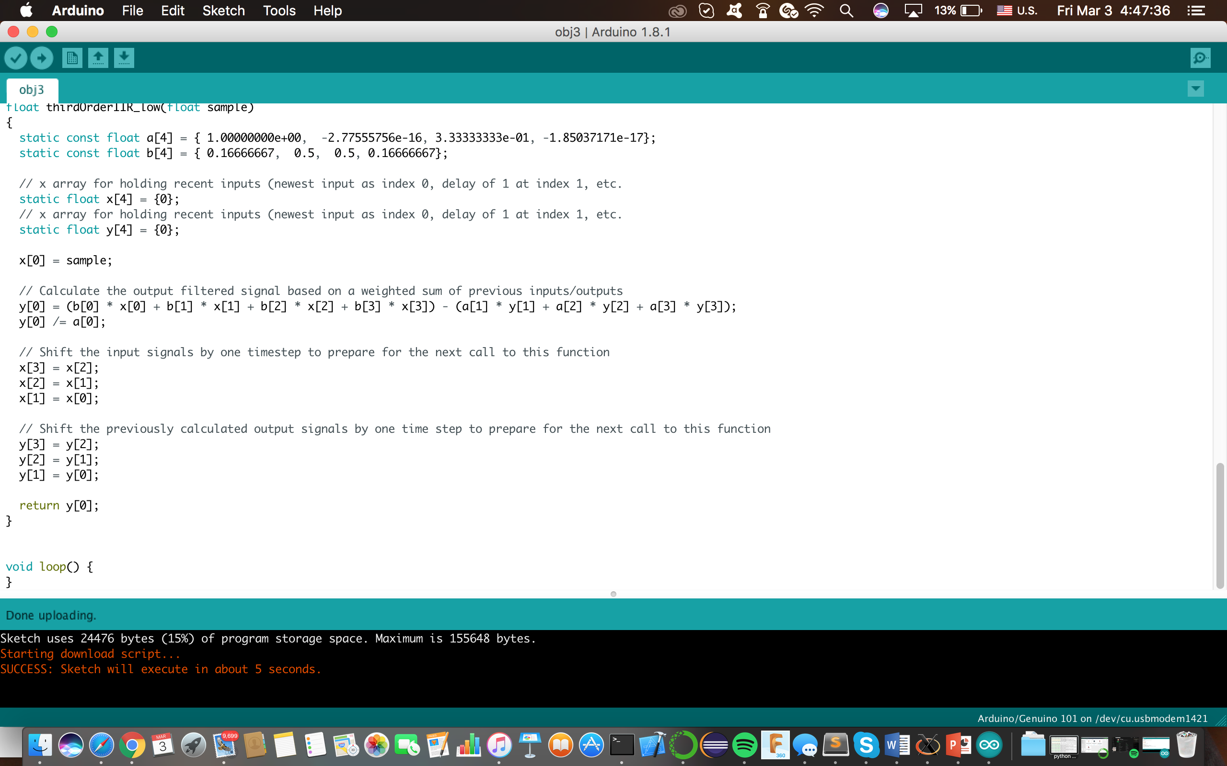

Figure 18: Python code for Objective 3

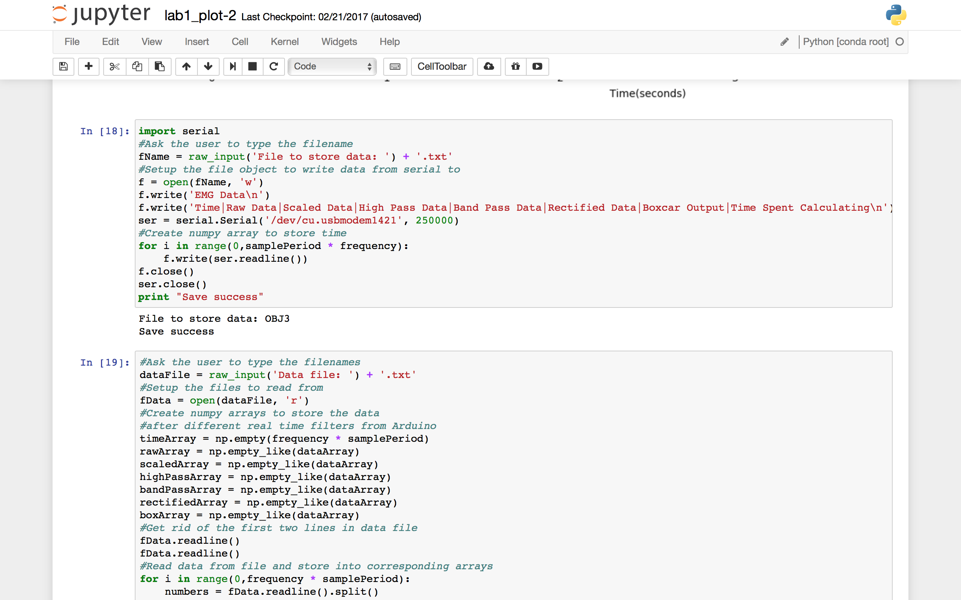

Figure 19: Python code for Objective 3

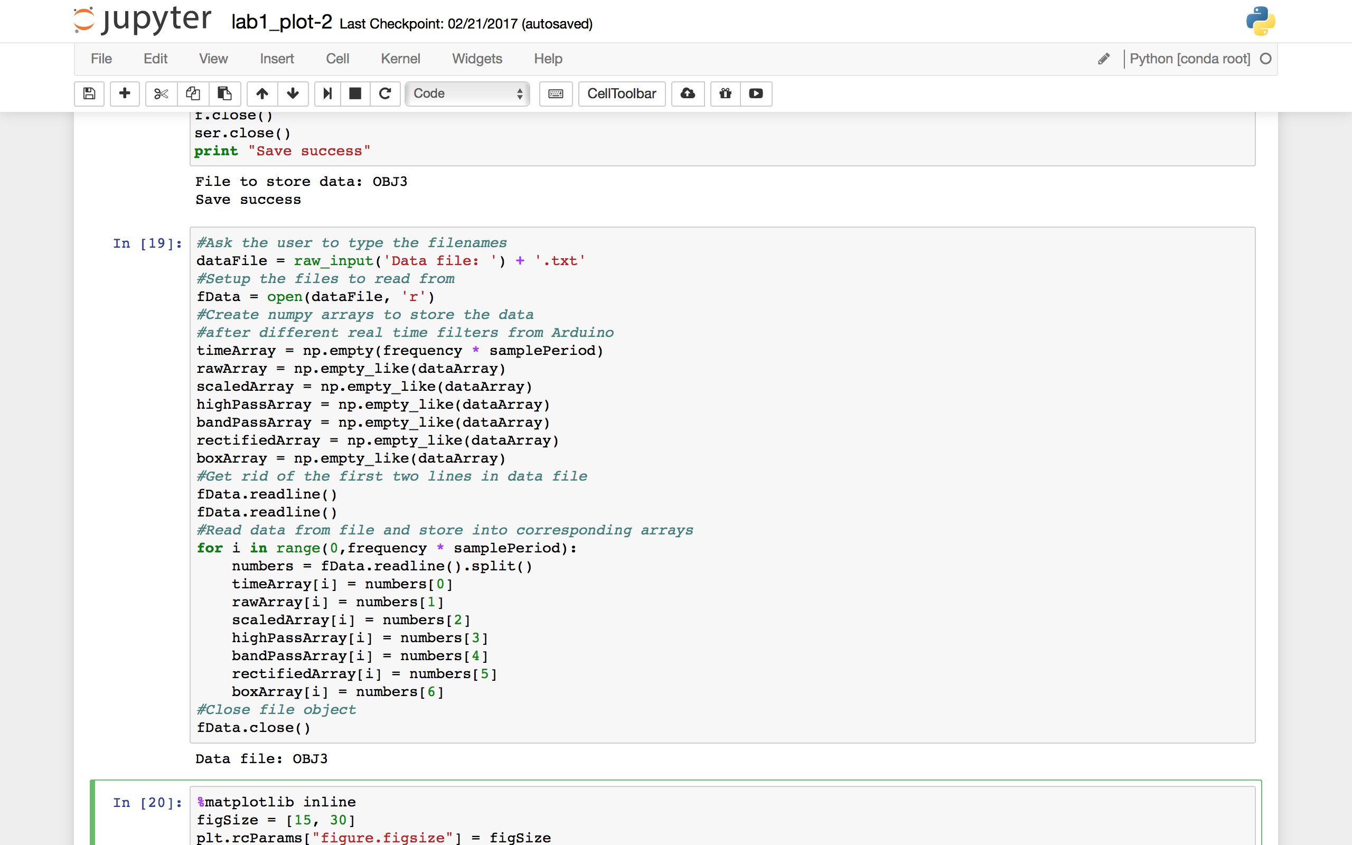

Figure 20: Python code for objective 3

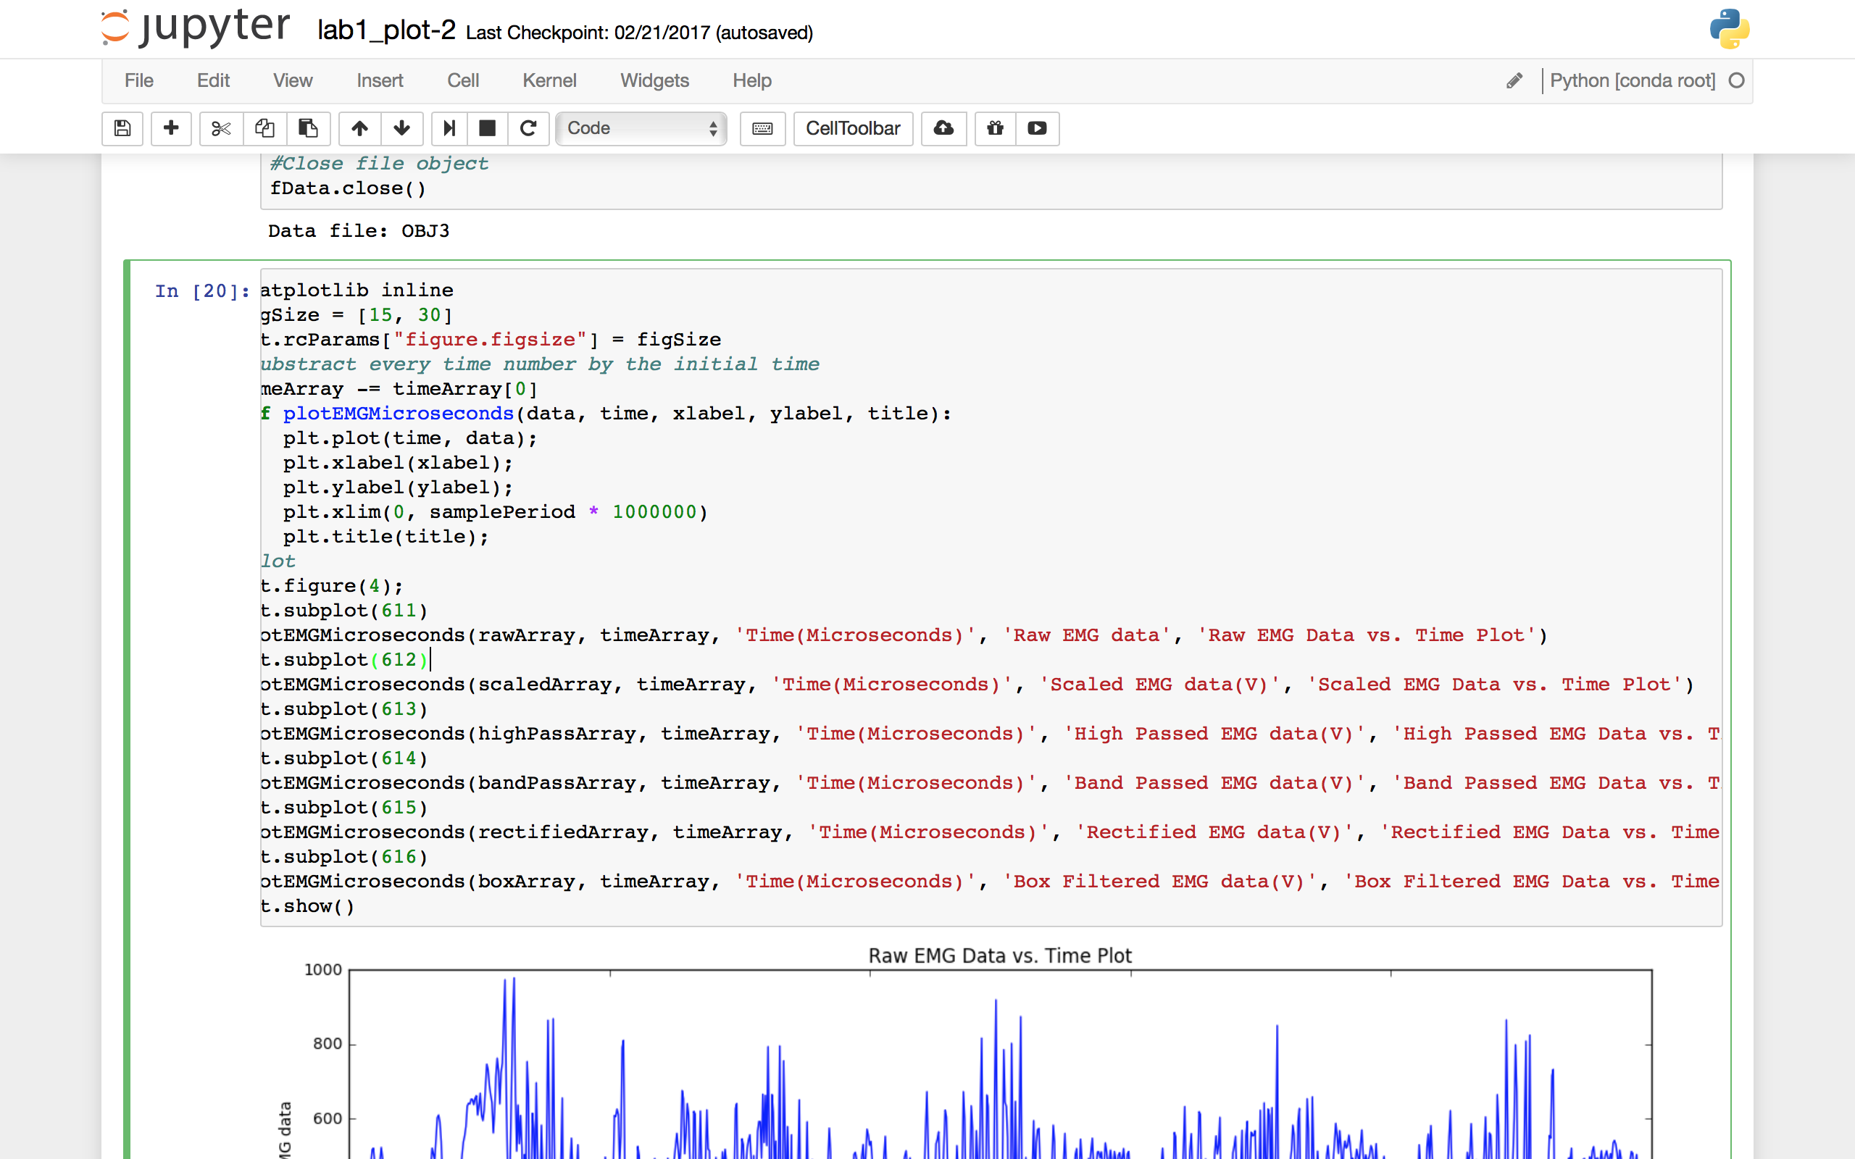

Figure 21: Raw data and Scaled EMG Data plots

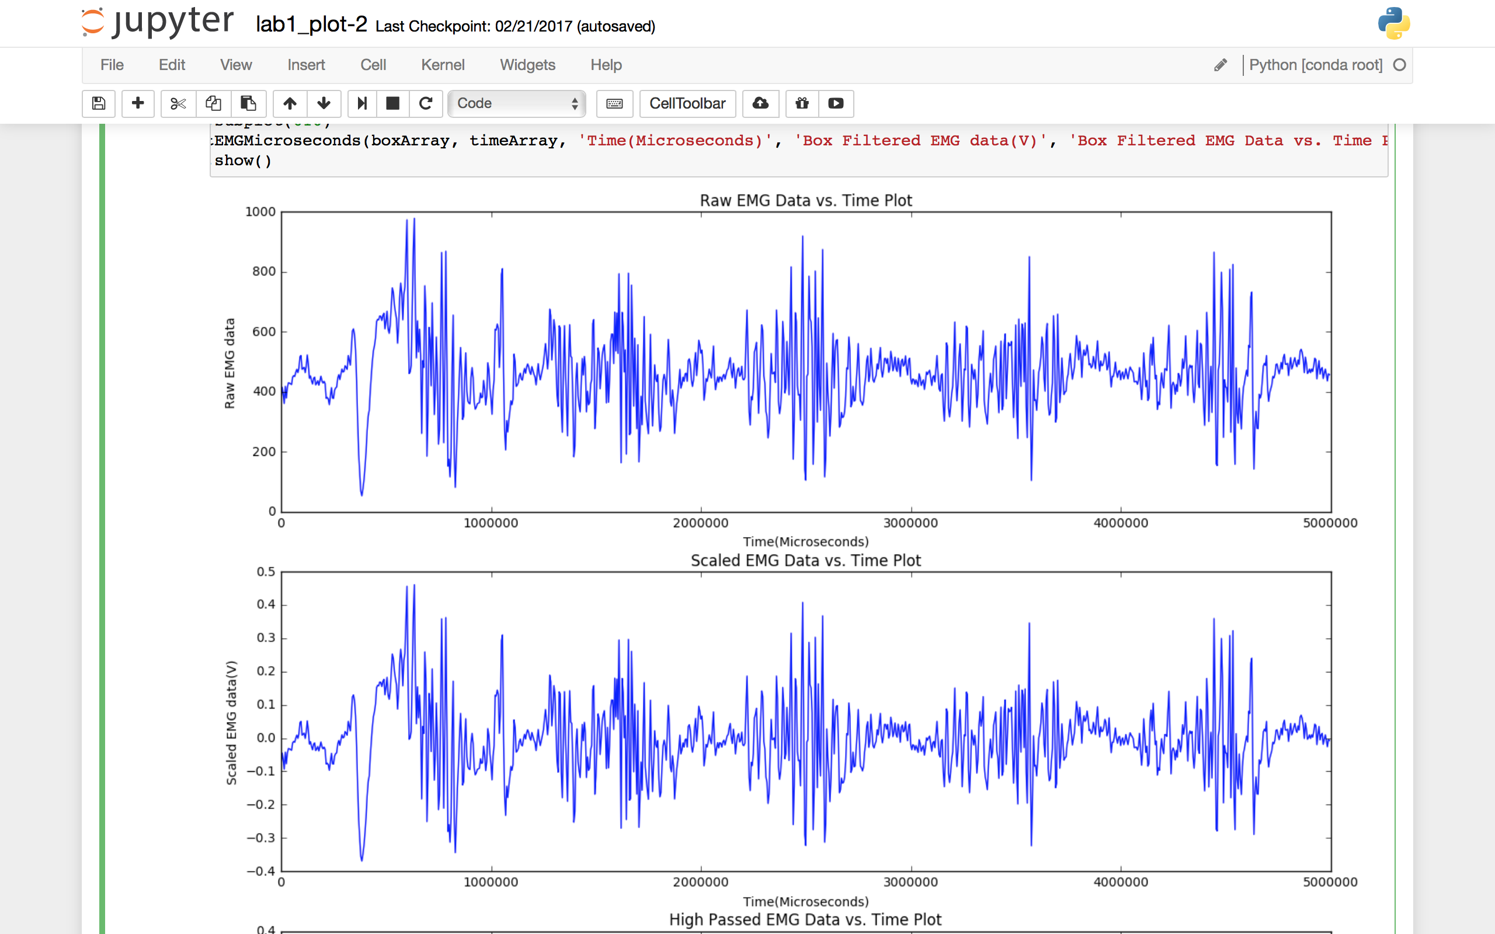

Figure 22: High Pass and Band Pass EMG Data plots

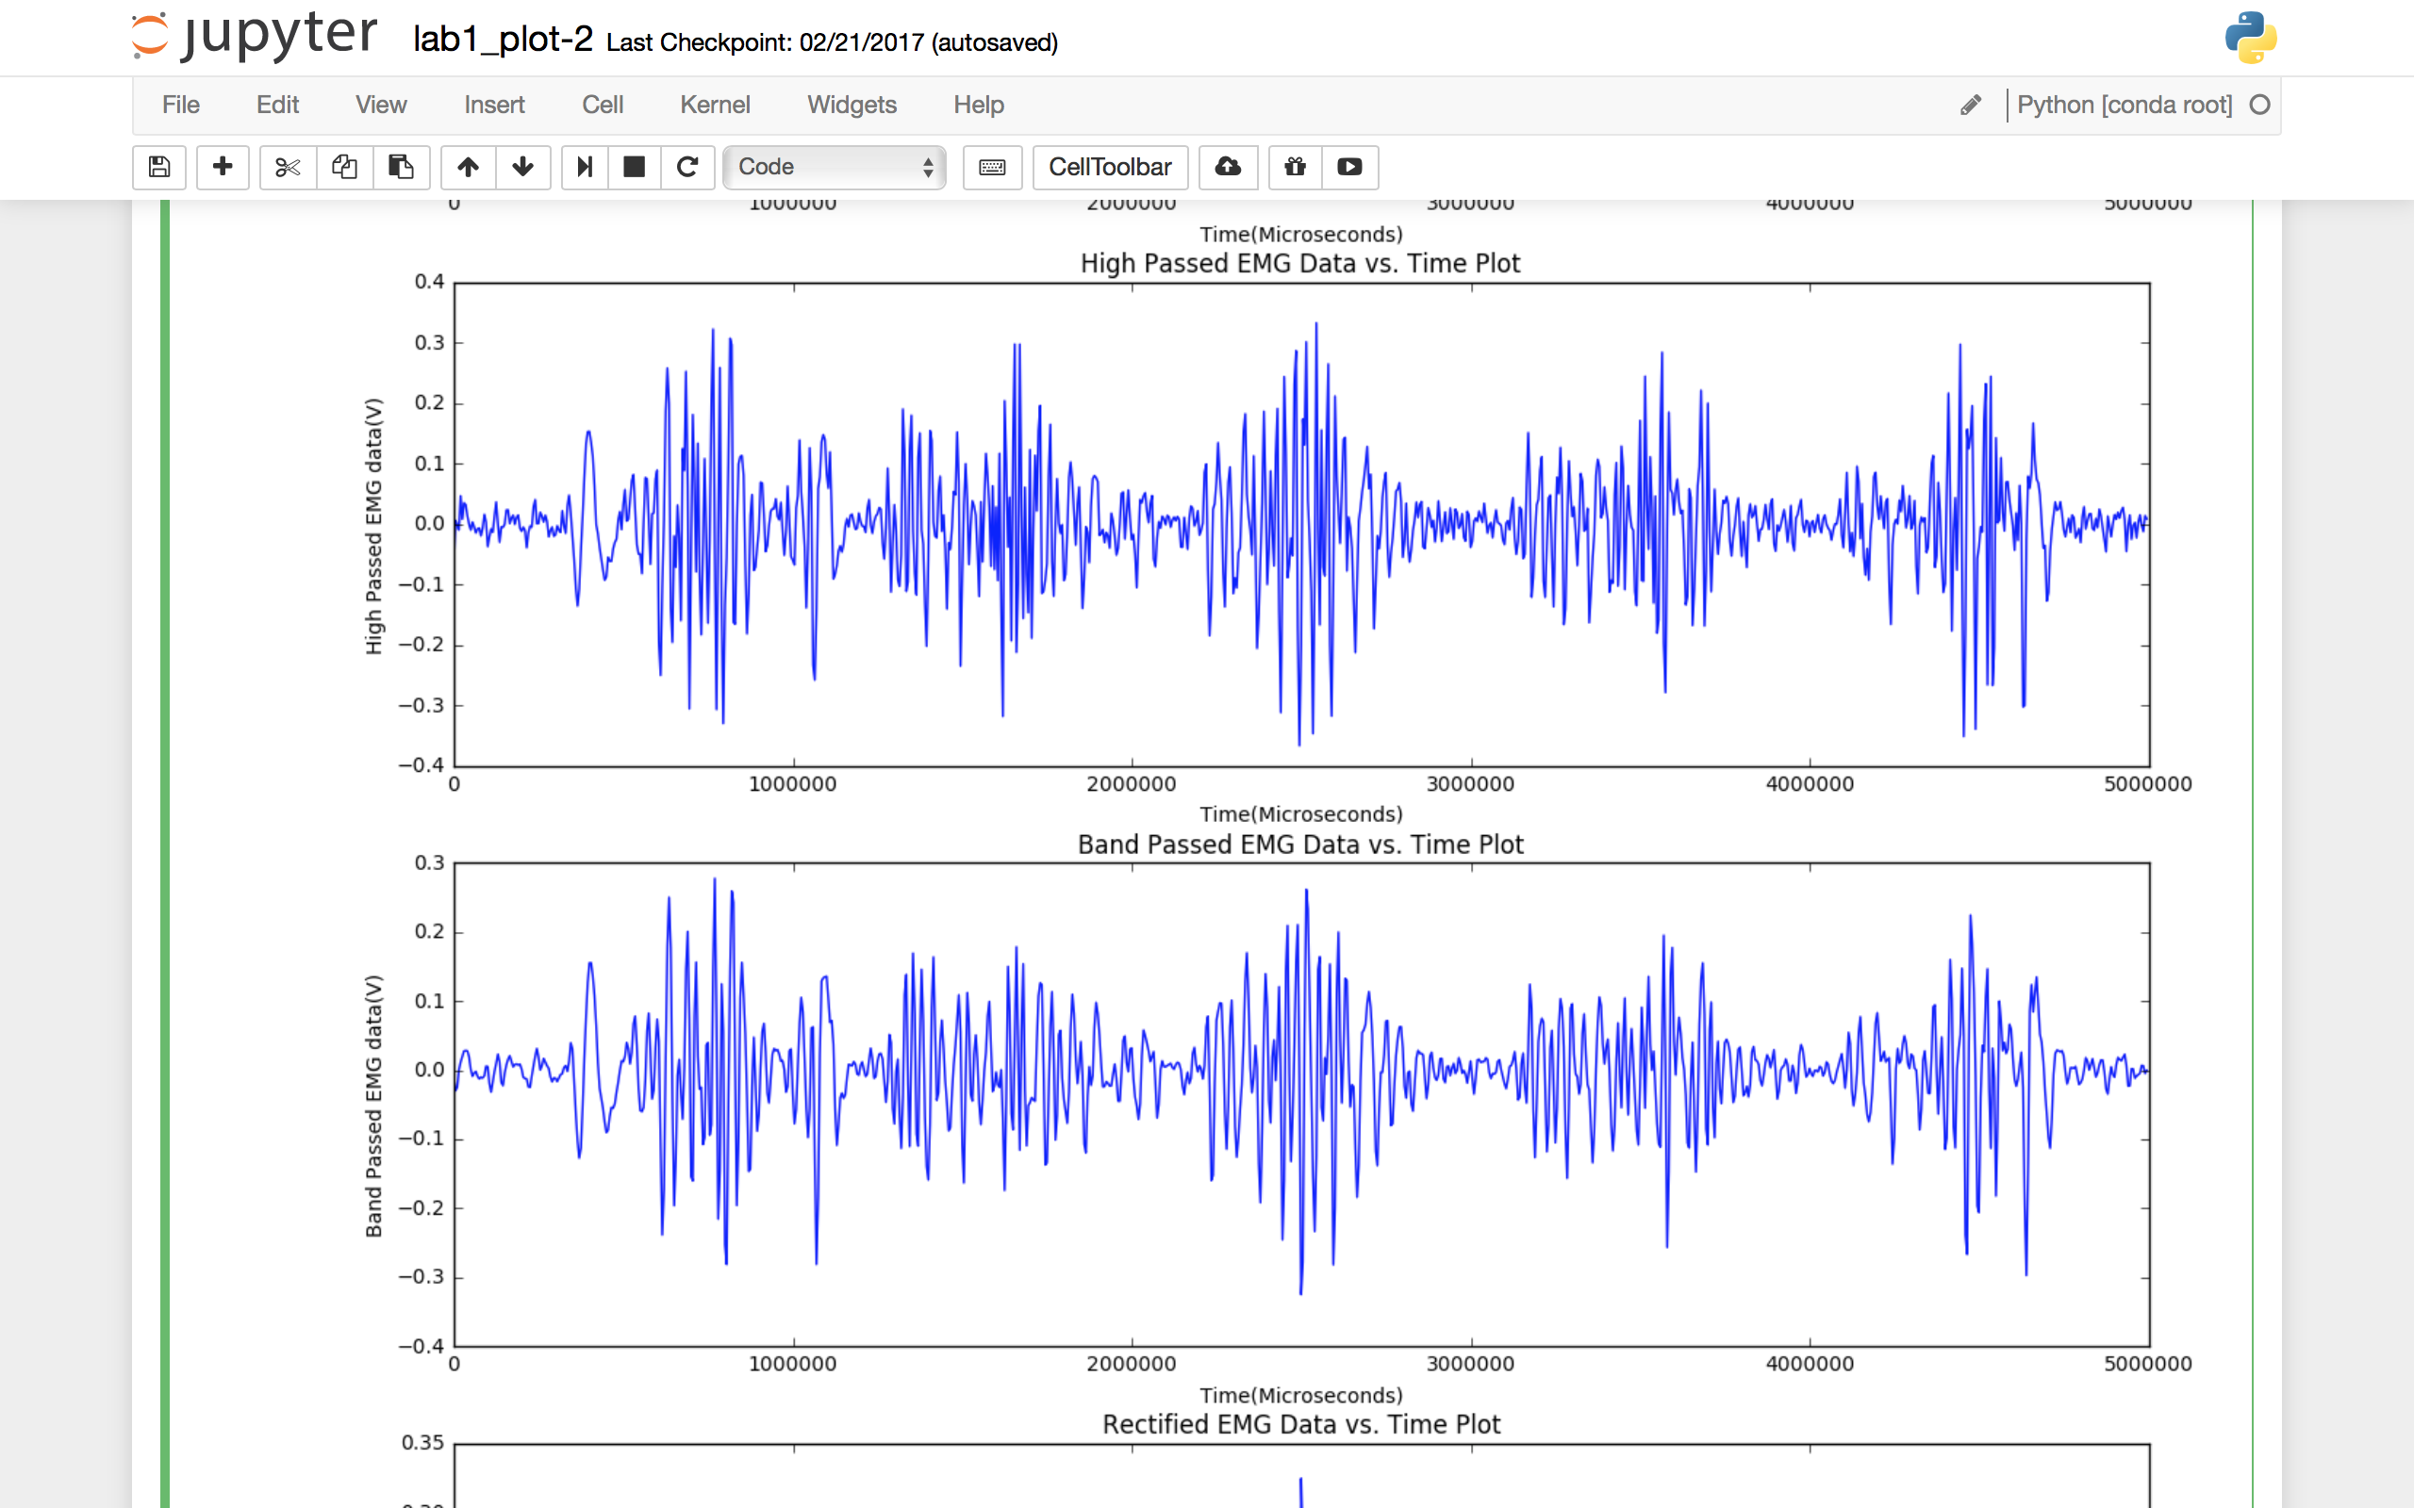

Figure 23: Rectified Data and Box filtered EMG Data plots

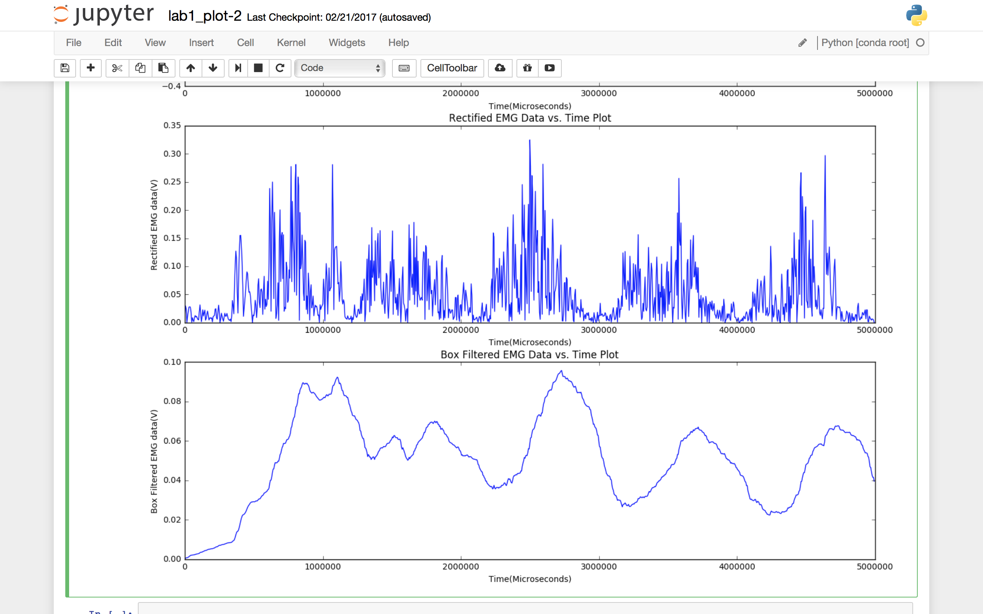

1. **Objective 4 – Streaming Arduino Data!**
   1. In this objective, we try to visualize EMG data signals in real time.
   2. We are using python plotting code to handle data streaming over the serial port.
   3. The Python code reads values from the serial port.
   4. Process the samples.
   5. Update the display every 100 milliseconds and do that for 2 seconds.
   6. The frequency remains constant = 200Hz.
   7. We achieve this by first initializing a set of plotting axes.
   8. Then, read 20 samples of processed signal from the serial port.
   9. Add the samples to the end of an array of data
   10. Check if the array contains more than 2 seconds of data.
   11. Plot the data from the array on the axes initiated above.
   12. Repeat the steps (from 8-11)

Figure 24: Real Time plotting for Objective 4 #1 iteration

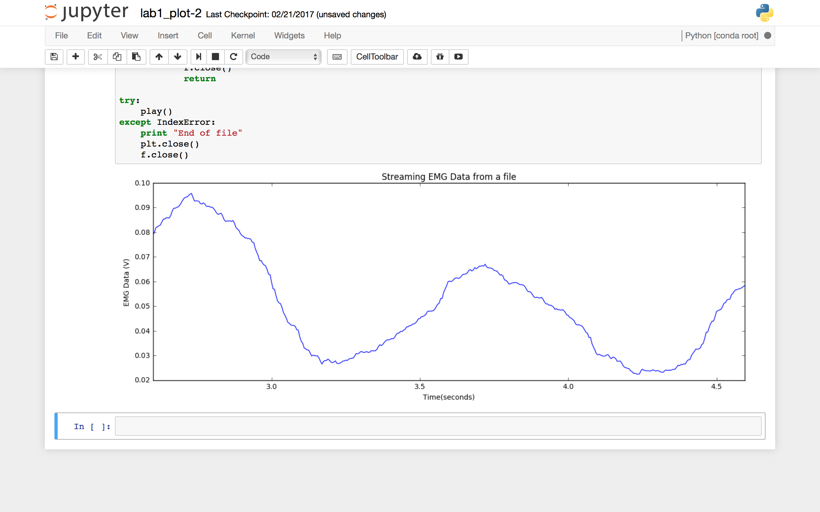

Figure 25: Real Time plotting for Objective 4 #2 iteration

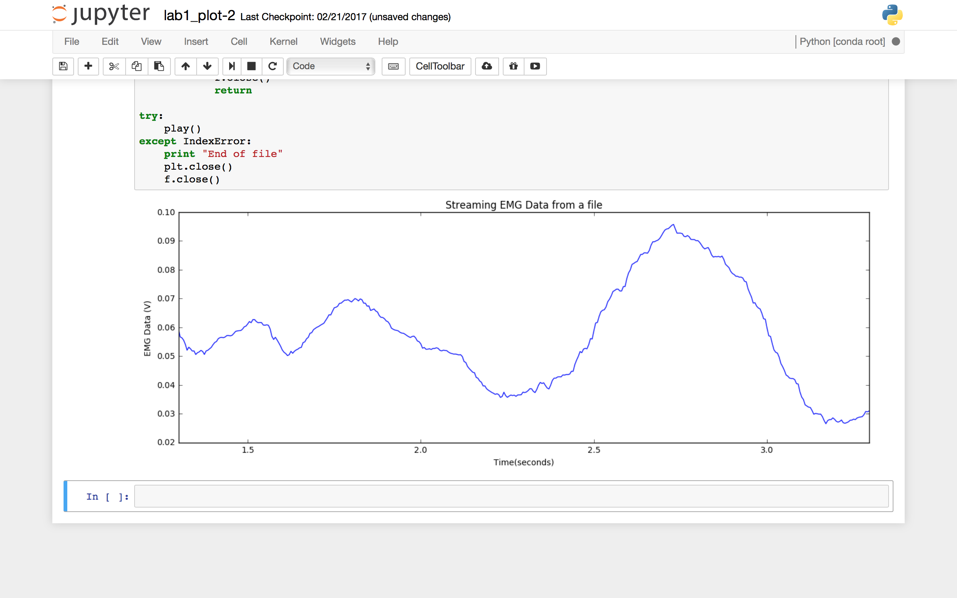

Figure 26: Real Time plotting for Objective 4 #3 iteration

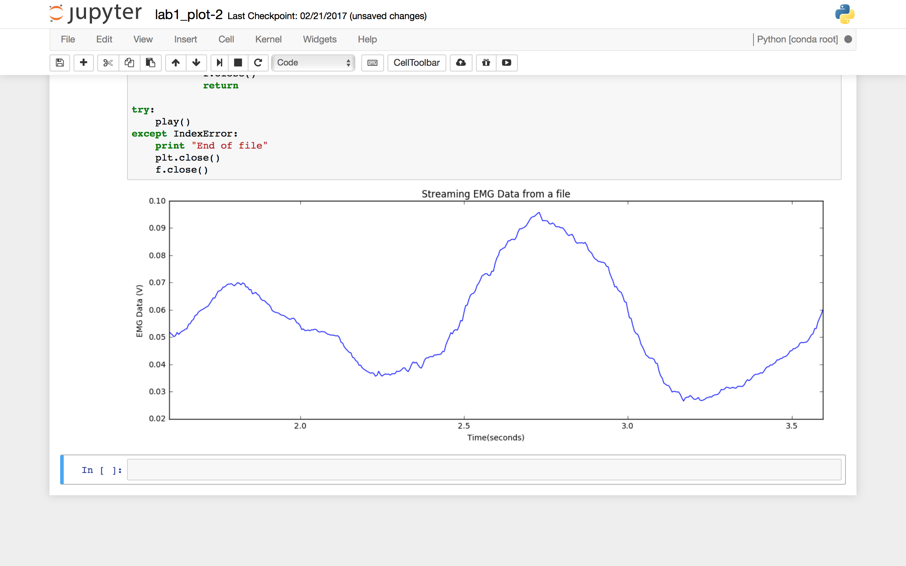

Figure 27: Python code for Objective 4

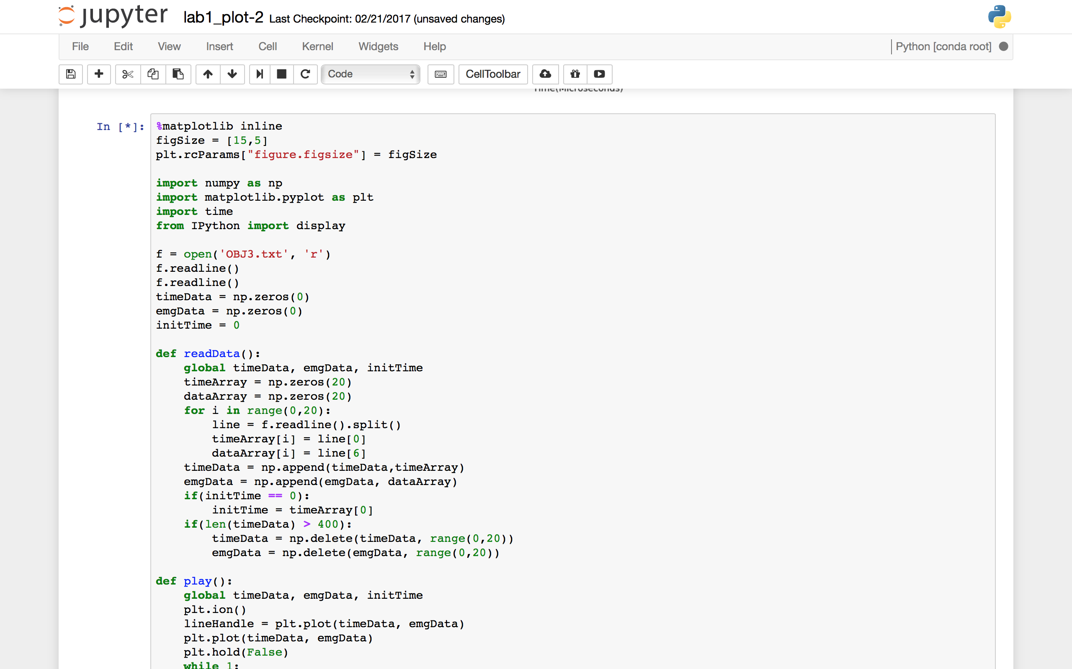

Figure 28: Python code for objective 4

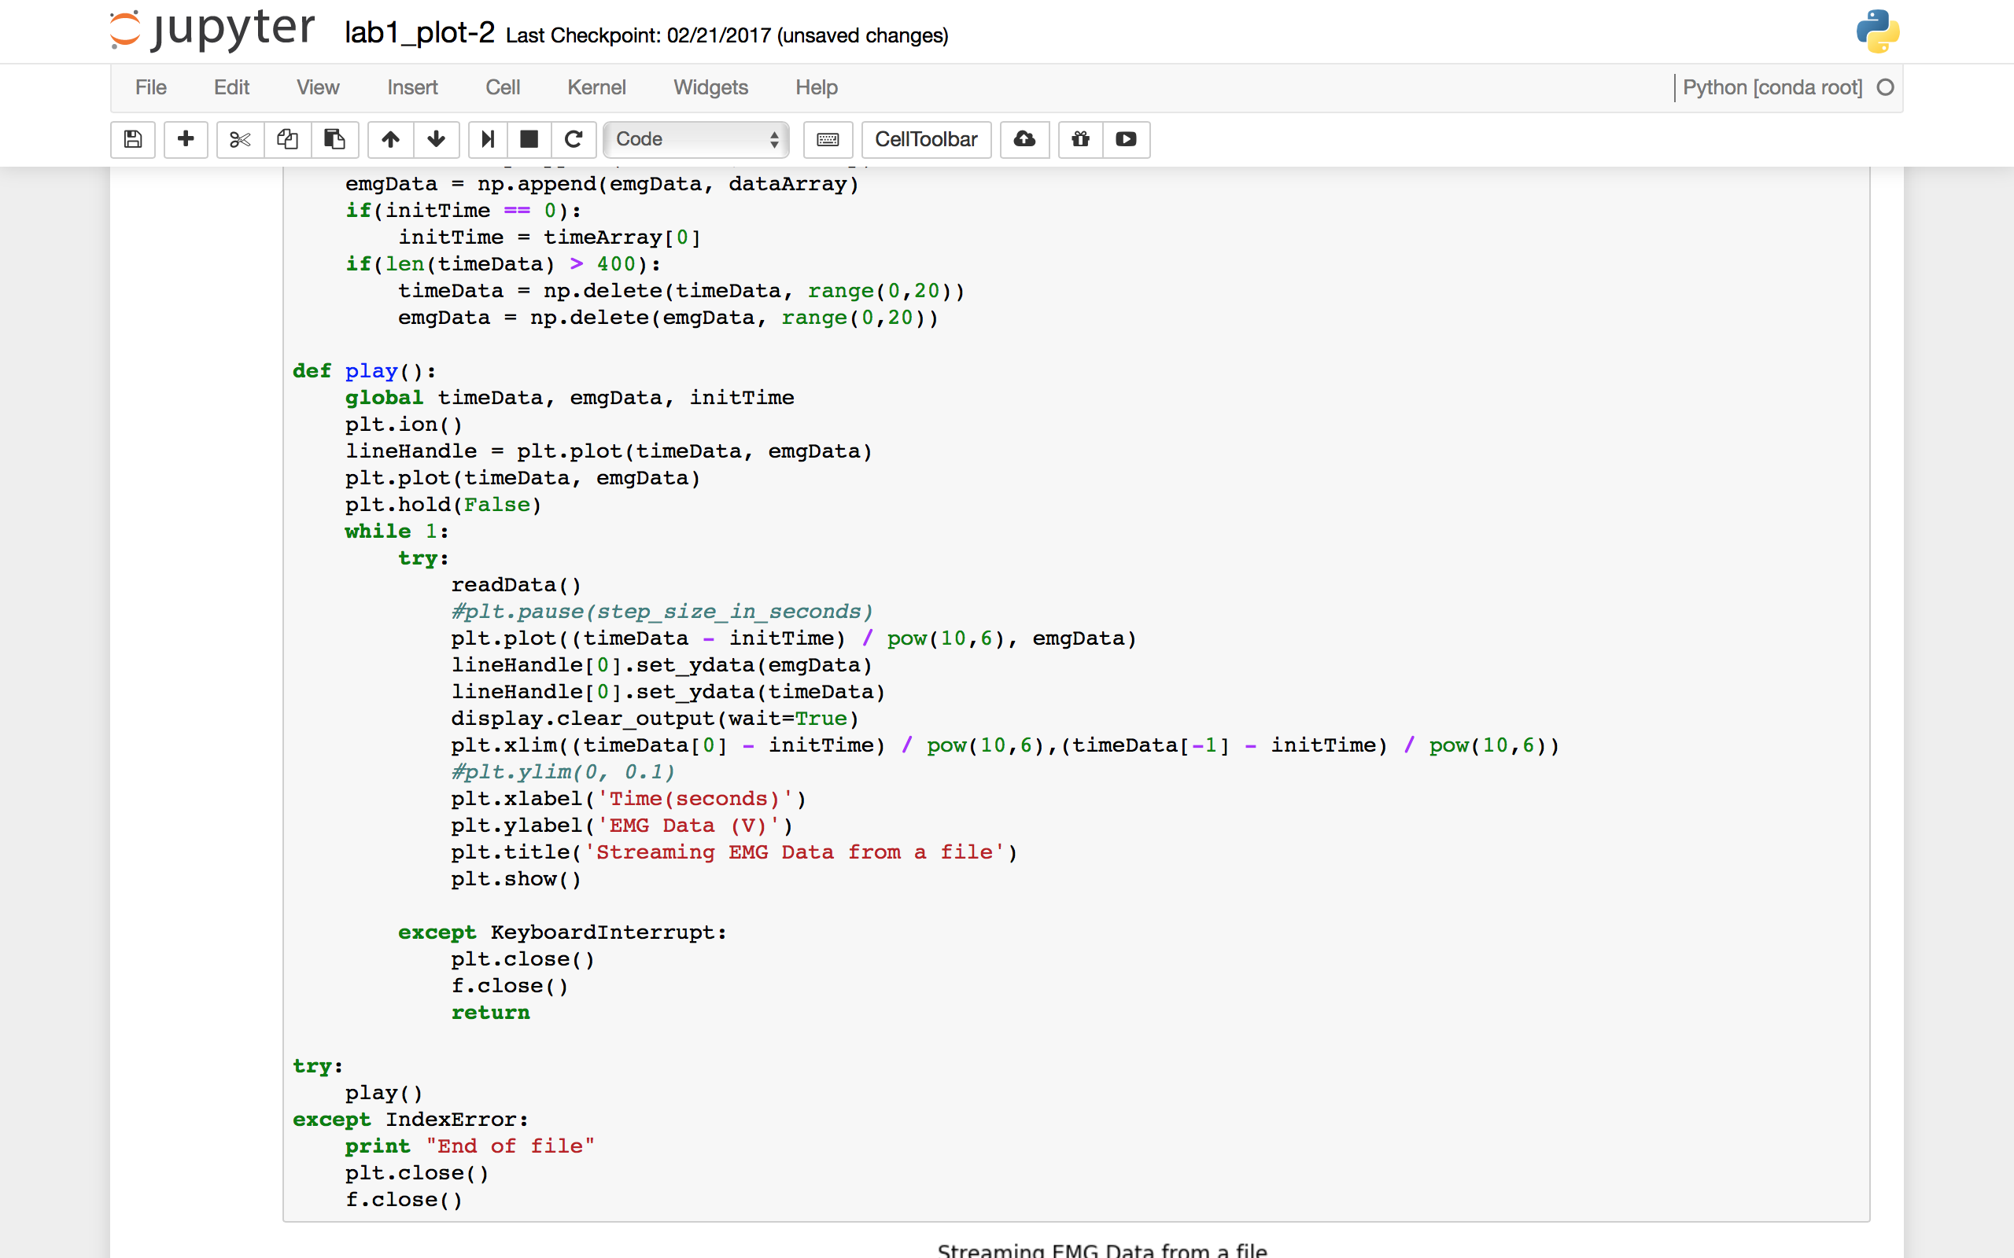

1. **Conclusion**

In this lab we were able to plot sampled data both from stored files and in real time.

1. **Appendix**

Attach the complete code here. Code should always be commented so it is clear what your program does. If the report requires that you submit a specific segment of code, make sure it is in the respective Objective section.

**Objective 1**

#include "CurieTimerOne.h"

#define FREQUENCY 200 //Setup the target sampling frequency (Hz)

long inTime, c;

int EMG;

void analogSample() //function when interrupt is asserted

{

EMG = analogRead(A0);

c++;

Serial.print(c);

Serial.print("\t");

Serial.print(EMG);

Serial.print("\t");

Serial.println(micros() - inTime);

}

void setup() {

//Setup for Analog input pins

pinMode(A0, INPUT);

Serial.begin(115200); //Setup serial at 115200 baud

while (!Serial); //Wait until Serial Monitor is opened

int period = 1000000 / FREQUENCY; //Setup the sampling period

CurieTimerOne.start(period, &analogSample); //set timer and callback to Analog Sampling

inTime = micros(); //Get an initial time

}

void loop() {

}

ort numpy as np

import matplotlib.pyplot as plt

frequency = 200

samplePeriod = 5

import serial

#Ask the user to type the filename

fName = raw_input('File to store data: ') + '.txt'

#Setup the file object to write data from serial to

f = open(fName, 'w')

f.write('EMG Data\n')

f.write('No\tRaw Data\tTime(Microseconds)\n')

ser = serial.Serial('/dev/cu.usbmodem1421', 115200)

#Create numpy array to store time

for i in range(0,samplePeriod * frequency):

f.write(ser.readline())

f.close()

ser.close()

print "Save success"

%matplotlib inline

figSize = [15, 20]

plt.rcParams["figure.figsize"] = figSize

#Ask the user to type the filenames

dataFile = raw_input('Data file: ') + '.txt'

#Setup the files to read from

fData = open(dataFile, 'r')

#Create numpy array to store time

dataArray = np.empty(frequency * samplePeriod)

timeArray = np.empty_like(dataArray)

#Get rid of the first two lines in data file

fData.readline()

fData.readline()

for i in range(0,frequency * samplePeriod):

numbers = fData.readline().split()

dataArray[i] = numbers[1]

timeArray[i] = numbers[2]

fData.close()

scaledDataArray = ((dataArray / 1023) * 3.3 - 1.5) / 3600 #Scale raw data

scaledTimeArray = timeArray / 10**6 #Scale time array

#Plot

plt.figure(1);

ax1 = plt.subplot(211)

ax1.plot(timeArray, dataArray);

plt.xlabel('Time(Microseconds)');

plt.ylabel('raw data');

plt.xlim(0, samplePeriod * 10**6)

plt.title('Raw Data from Arduino Analog Input vs Time Plot');

ax2 = plt.subplot(212)

plt.plot(scaledTimeArray, scaledDataArray);

plt.xlabel('Time(seconds)');

plt.ylabel('EMG data(V)');

plt.xlim(0, samplePeriod)

plt.title('Scaled Data from Arduino Analog Input vs Time Plot');

plt.tight_layout()

plt.show()

**Objective 2**

%matplotlib inline

figSize = [15, 20]

plt.rcParams["figure.figsize"] = figSize #prevents graphs to overlap

from scipy import signal

b_high, a_high = signal.butter(3, 0.1, 'high', analog=False)

high_pass_data = signal.lfilter(b_high, a_high, scaledDataArray) #high_pass Filter applied here

b_low, a_low = signal.butter(3, .5, 'low', analog=False)

low_pass_data = signal.lfilter(b_low, a_low, scaledDataArray) #low_pass Filter applied here

band_pass_data = signal.lfilter(b_low, a_low, high_pass_data)

print b_high #printing b_high to check value

print a_high #printing a_high to check value

print b_low #printing b_low to check value

print a_low #printing a_low to check value

def plotEMG(data, time, xlabel, ylabel, title):

plt.plot(time, data);

plt.xlabel(xlabel); #marks x axis

plt.ylabel(ylabel); #marks y axis

plt.xlim(0, samplePeriod)

plt.title(title); #gives the graph a title

plt.figure(2)

plt.subplot(411)

plotEMG(scaledDataArray, scaledTimeArray, 'Time(seconds)', 'EMG data(V)', 'Original Data')

plt.subplot(412)

plotEMG(high_pass_data, scaledTimeArray, 'Time(seconds)', 'EMG data(V)', 'Data after high pass filter')

plt.subplot(413)

plotEMG(low_pass_data, scaledTimeArray, 'Time(seconds)', 'EMG data(V)', 'Data after low pass filter')

plt.subplot(414)

plotEMG(band_pass_data, scaledTimeArray, 'Time(seconds)', 'EMG data(V)', 'Data after band pass filter')

plt.show()

%matplotlib inline

figSize = [15, 15]

plt.rcParams["figure.figsize"] = figSize

rectified_data = np.absolute(band_pass_data)

box = signal.boxcar(100)

print box

smoothed_data =signal.lfilter(box, 1, rectified_data)

plt.figure(3)

plt.subplot(311)

plotEMG(band_pass_data, scaledTimeArray, 'Time(seconds)', 'EMG data(V)', 'Filtered Data')

plt.subplot(312)

plotEMG(rectified_data, scaledTimeArray, 'Time(seconds)', 'EMG data(V)', 'Rectified Data')

plt.subplot(313)

plotEMG(smoothed_data, scaledTimeArray, 'Time(seconds)', 'EMG data(V)', 'Smoothed Data')

plt.show()

**Objective 3**

import serial

#Ask the user to type the filename

fName = raw_input('File to store data: ') + '.txt'

#Setup the file object to write data from serial to

f = open(fName, 'w')

f.write('EMG Data\n')

f.write('Time|Raw Data|Scaled Data|High Pass Data|Band Pass Data|Rectified Data|Boxcar Output|Time Spent Calculating\n')

ser = serial.Serial('/dev/cu.usbmodem1421', 250000)

#Create numpy array to store time

for i in range(0,samplePeriod * frequency):

f.write(ser.readline())

f.close()

ser.close()

print "Save success"

#Ask the user to type the filenames

dataFile = raw_input('Data file: ') + '.txt'

#Setup the files to read from

fData = open(dataFile, 'r')

#Create numpy arrays to store the data

#after different real time filters from Arduino

timeArray = np.empty(frequency * samplePeriod)

rawArray = np.empty_like(dataArray)

scaledArray = np.empty_like(dataArray)

highPassArray = np.empty_like(dataArray)

bandPassArray = np.empty_like(dataArray)

rectifiedArray = np.empty_like(dataArray)

boxArray = np.empty_like(dataArray)

#Get rid of the first two lines in data file

fData.readline()

fData.readline()

#Read data from file and store into corresponding arrays

for i in range(0,frequency * samplePeriod):

numbers = fData.readline().split()

timeArray[i] = numbers[0]

rawArray[i] = numbers[1]

scaledArray[i] = numbers[2]

highPassArray[i] = numbers[3]

bandPassArray[i] = numbers[4]

rectifiedArray[i] = numbers[5]

boxArray[i] = numbers[6]

#Close file object

fData.close()

%matplotlib inline

figSize = [15, 30]

plt.rcParams["figure.figsize"] = figSize

#Substract every time number by the initial time

timeArray -= timeArray[0]

def plotEMGMicroseconds(data, time, xlabel, ylabel, title):

plt.plot(time, data);

plt.xlabel(xlabel);

plt.ylabel(ylabel);

plt.xlim(0, samplePeriod * 1000000)

plt.title(title);

#Plot

plt.figure(4);

plt.subplot(611)

plotEMGMicroseconds(rawArray, timeArray, 'Time(Microseconds)', 'Raw EMG data', 'Raw EMG Data vs. Time Plot')

plt.subplot(612)

plotEMGMicroseconds(scaledArray, timeArray, 'Time(Microseconds)', 'Scaled EMG data(V)', 'Scaled EMG Data vs. Time Plot')

plt.subplot(613)

plotEMGMicroseconds(highPassArray, timeArray, 'Time(Microseconds)', 'High Passed EMG data(V)', 'High Passed EMG Data vs. Time Plot')

plt.subplot(614)

plotEMGMicroseconds(bandPassArray, timeArray, 'Time(Microseconds)', 'Band Passed EMG data(V)', 'Band Passed EMG Data vs. Time Plot')

plt.subplot(615)

plotEMGMicroseconds(rectifiedArray, timeArray, 'Time(Microseconds)', 'Rectified EMG data(V)', 'Rectified EMG Data vs. Time Plot')

plt.subplot(616)

plotEMGMicroseconds(boxArray, timeArray, 'Time(Microseconds)', 'Box Filtered EMG data(V)', 'Box Filtered EMG Data vs. Time Plot')

plt.show()

#include "CurieTimerOne.h"

#define FREQUENCY 200 //Setup the target sampling frequency (Hz)s

void setup() {

//Setup for Analog input pins

pinMode(A0, INPUT);

Serial.begin(250000); //Setup serial at 250000 baud

while (!Serial); //Wait until Serial Monitor is opened

int period = 1000000 / FREQUENCY; //Setup the sampling period

CurieTimerOne.start(period, &analogSampleIsr);// set timer and callback to Analog Sampling

}

void analogSampleIsr() // callback function when interrupt is asserted

{

static long initTime, timeSpent;

static double rawData, EMGData, highPassData, bandPassData, rectifiedData, boxOutput;

rawData = analogRead(A0);

initTime = micros();

EMGData = ((double(rawData) / 1023.0) * 3300 - 1500) / 3600.0;

highPassData = thirdOrderIIR_high(EMGData);

bandPassData = thirdOrderIIR_low(highPassData);

rectifiedData = abs(bandPassData);

boxOutput = boxcarFilterSample(rectifiedData);

timeSpent = micros() - initTime;

Serial.print(initTime); Serial.print(" "); Serial.print(rawData); Serial.print(" ");

Serial.print(EMGData, 5); Serial.print(" "); Serial.print(highPassData, 5); Serial.print(" ");

Serial.print(bandPassData, 5); Serial.print(" "); Serial.print(rectifiedData, 5); Serial.print(" ");

Serial.print(boxOutput, 5); Serial.print(" "); Serial.println(timeSpent, 5);

}

float boxcarFilterSample(float sample)

{

static const int boxcarWidth = 100; // Change this value to alter boxcar length

static float recentSamples[boxcarWidth] = {0}; // hold onto recent samples

static int readIndex = 0; // the index of the current reading

static float total = 0; // the running total

static float average = 0; // the average

// subtract the last reading:

total = total - recentSamples[readIndex];

// add new sample to list (overwrite oldest sample)

recentSamples[readIndex] = sample;

// add the reading to the total:

total = total + recentSamples[readIndex];

// advance to the next position in the array:

readIndex = readIndex + 1;

// if we're at the end of the array...

if (readIndex >= boxcarWidth) {

// ...wrap around to the beginning:

readIndex = 0;

}

// calculate the average:

average = total / boxcarWidth;

// send it to the computer as ASCII digits

return average;

}

float thirdOrderIIR_high(float sample)

{

static const float a[4] = { 1. , -2.37409474, 1.92935567, -0.53207537};

static const float b[4] = { 0.72944072, -2.18832217, 2.18832217, -0.72944072};

// x array for holding recent inputs (newest input as index 0, delay of 1 at index 1, etc.

static float x[4] = {0};

// x array for holding recent inputs (newest input as index 0, delay of 1 at index 1, etc.

static float y[4] = {0};

x[0] = sample;

// Calculate the output filtered signal based on a weighted sum of previous inputs/outputs

y[0] = (b[0] * x[0] + b[1] * x[1] + b[2] * x[2] + b[3] * x[3]) - (a[1] * y[1] + a[2] * y[2] + a[3] * y[3]);

y[0] /= a[0];

// Shift the input signals by one timestep to prepare for the next call to this function

x[3] = x[2];

x[2] = x[1];

x[1] = x[0];

// Shift the previously calculated output signals by one time step to prepare for the next call to this function

y[3] = y[2];

y[2] = y[1];

y[1] = y[0];

return y[0];

}

float thirdOrderIIR_low(float sample)

{

static const float a[4] = { 1.00000000e+00, -2.77555756e-16, 3.33333333e-01, -1.85037171e-17};

static const float b[4] = { 0.16666667, 0.5, 0.5, 0.16666667};

// x array for holding recent inputs (newest input as index 0, delay of 1 at index 1, etc.

static float x[4] = {0};

// x array for holding recent inputs (newest input as index 0, delay of 1 at index 1, etc.

static float y[4] = {0};

x[0] = sample;

// Calculate the output filtered signal based on a weighted sum of previous inputs/outputs

y[0] = (b[0] * x[0] + b[1] * x[1] + b[2] * x[2] + b[3] * x[3]) - (a[1] * y[1] + a[2] * y[2] + a[3] * y[3]);

y[0] /= a[0];

// Shift the input signals by one timestep to prepare for the next call to this function

x[3] = x[2];

x[2] = x[1];

x[1] = x[0];

// Shift the previously calculated output signals by one time step to prepare for the next call to this function

y[3] = y[2];

y[2] = y[1];

y[1] = y[0];

return y[0];

}

void loop() {

}

**Objective 4**

%matplotlib inline

figSize = [15,5]

plt.rcParams["figure.figsize"] = figSize

import numpy as np

import matplotlib.pyplot as plt

import time

from IPython import display

f = open('OBJ3.txt', 'r')

f.readline()

f.readline()

timeData = np.zeros(0)

emgData = np.zeros(0)

initTime = 0

def readData():

global timeData, emgData, initTime

timeArray = np.zeros(20)

dataArray = np.zeros(20)

for i in range(0,20):

line = f.readline().split()

timeArray[i] = line[0]

dataArray[i] = line[6]

timeData = np.append(timeData,timeArray)

emgData = np.append(emgData, dataArray)

if(initTime == 0):

initTime = timeArray[0]

if(len(timeData) > 400):

timeData = np.delete(timeData, range(0,20))

emgData = np.delete(emgData, range(0,20))

def play():

global timeData, emgData, initTime

plt.ion()

lineHandle = plt.plot(timeData, emgData)

plt.plot(timeData, emgData)

plt.hold(False)

while 1:

try:

readData()

#plt.pause(step_size_in_seconds)

plt.plot((timeData - initTime) / pow(10,6), emgData)

lineHandle[0].set_ydata(emgData)

lineHandle[0].set_ydata(timeData)

display.clear_output(wait=True)

plt.xlim((timeData[0] - initTime) / pow(10,6),(timeData[-1] - initTime) / pow(10,6))

#plt.ylim(0, 0.1)

plt.xlabel('Time(seconds)')

plt.ylabel('EMG Data (V)')

plt.title('Streaming EMG Data from a file')

plt.show()

except KeyboardInterrupt:

plt.close()

f.close()

return

try:

play()

except IndexError:

print "End of file"

plt.close()

f.close()